MANAGERIAL ECONOMICS
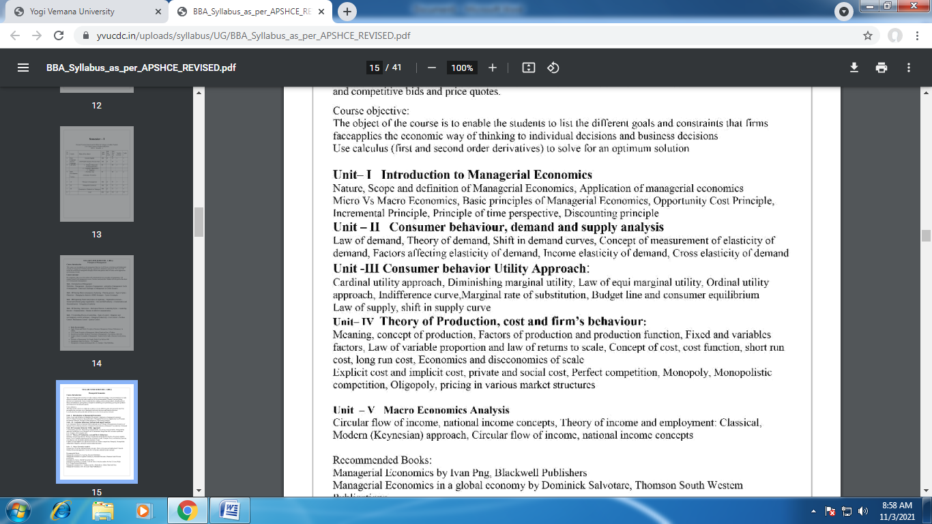

UNIT-I
INTRODUCTION TO MANAGERIAL ECONOMICS
Imagine for a while that you have finished your studies and have joined as an engineer in a manufacturing organization. What do you do there? You plan to produce maximum quantity of goods of a given quality at a reasonable cost. On the other hand, if you are a sale manager, you have to sell a maximum amount of goods with minimum advertisement costs. In other words, you want to minimize your costs and maximize your returns and by doing so, you are practicing the principles of managerial economics.
Managers, in their day-to-day activities, are always confronted with several issues such as how much quantity is to be supplied; at what price; should the product be made internally; or whether Unit-IV: Market Structure and Pricing Practices Unit-V: Macro Economics & Business it should be bought from outside; how much quantity is to be produced to make a given amount of profit and so on. Managerial economics provides us a basic insight into seeking solutions for managerial problems. Economics, as the name itself implies, is an offshoot of two distinct disciplines: Economics and Management. In other words, it is necessary to understand what these disciplines are, at least in brief, to understand the nature and scope of managerial economics.
INTRODUCTION TO ECONOMICS :
Economics is a study of human activity both at individual and national level. The economists of early age treated economics merely as the science of wealth. The reason for this is clear. Every one of us in involved in efforts aimed at earning money and spending this money to satisfy our wants such as food, Clothing, shelter, and others. Such activities of earning and spending money are called Economic activities”. It was only during the eighteenth century that Adam Smith, the Father of Economics, defined economics as the study of nature and uses of national wealth’.
Dr. Alfred Marshall, one of the greatest economists of the nineteenth century, writes “Economics is a study of man’s actions in the ordinary business of life: it enquires how he gets his income and how he uses it”. Thus, it is one side, a study of wealth; and on the other, and more important side; it is the study of man. As Marshall observed, the chief aim of economics is to promote ‘human welfare’, but not wealth.
Prof. Lionel Robbins defined Economics as “the science, which studies human behaviour as a relationship between ends and scarce means which have alternative uses”. With this, the focus of economics shifted from ‘wealth’ to human behaviour.

CONCEPTS OF MICRO AND MACRO ECONOMICS:
‘Economics’ is defined as the study of how the humans work together to convert limited resources into goods and services to satisfy their wants (unlimited) and how they distribute the same among themselves. Economics has been divided into two broad parts i.e. Micro Economics and Macro Economics. Here, in the given article we’ve broken down the concept and all the important differences between micro economics and macro economics, in tabular form, have a look.
MICROECONOMICS The term ‘micro’ means small. The study of an individual consumer or a firm is called microeconomics (also called the Theory of Firm). Micro means ‘one millionth’. Microeconomics deals with behavior and problems of single individual and of micro organization. Managerial economics has its roots in microeconomics and it deals with the micro or individual enterprises. It is concerned with the application of the concepts such as price theory, Law of Demand and theories of market structure and so on.
MACROECONOMICS The term ‘macro’ means large. The study of ‘aggregate or total level of economic activity in a country is called macroeconomics. It studies the flow of economics resources or factors of production (such as land, labour, capital, organisation and technology) from the resource owner to the business firms and then from the business firms to the households. It deals with total aggregates, for instance, total national income total employment, output and total investment. It studies the interrelations among various aggregates and examines their nature and behaviour, their determination and causes of fluctuations in the. It deals with the price level in general, instead of studying the prices of individual commodities. It is concerned with the level of employment in the economy. It discusses aggregate consumption, aggregate investment, price level, and payment, theories of employment, and so on. Though macroeconomics provides the necessary framework in term of government policies etc., for the firm to act upon dealing with analysis of business conditions, it has less direct relevance in the study of theory of firm. Micro and Macro Economics are not contradictory in nature, in fact, they are complementary. As every coin has two aspects- micro and macroeconomics are also the two aspects of the same coin, where one’s demerit is others merit and in this way they cover the whole economy. The only important thing which makes them different is the area of application.
MANAGEMENT:
Management is the science and art of getting things done through people in formally organized groups. It is necessary that every organisation be well managed to enable it to achieve its desired goals. Management includes a number of functions: Planning, organizing, staffing, directing, and controlling. The manager while directing the efforts of his staff communicates to them the goals, objectives, policies, and procedures; coordinates their efforts; motivates them to sustain their enthusiasm; and leads them to achieve the corporate goals.

INTRODUCTION
Managerial Economics is subject gained popularity in USA after the publication of the book Managerial Economics” by Joel Dean in 1951. Managerial Economics refers to the firm’s decision making process. It could be also interpreted as “Economics of Management” or “Economics of Management”. Managerial Economics is also called as “Industrial Economics” or “Business Economics”. As Joel Dean observes managerial economics shows how economic analysis can be used in formulating polices.
MEANING & DEFINITION:
In the words of E. F. Brigham and J. L. Pappas Managerial Economics is “the applications of economics theory and methodology to business administration practice”. M. H. Spencer and Louis Siegel man explain the “Managerial Economics is the integration of economic theory with business practice for the purpose of facilitating decision making and forward planning by management”. Managerial Economics, therefore, focuses on those tools and techniques, which are useful in decision-making.
NATURE OF MANAGERIAL ECONOMICS
Managerial economics is, perhaps, the youngest of all the social sciences. Since it originates from Economics, it has the basis features of economics, such as assuming that other things remaining the same.
The other features of managerial economics are explained as below:
(a) Close to microeconomics: Managerial economics is concerned with finding the solutions for different managerial problems of a particular firm. Thus, it is more close to microeconomics.
(b) Operates against the backdrop of macroeconomics: The macroeconomics conditions of the economy are also seen as limiting factors for the firm to operate. In other words, the managerial economist has to be aware of the limits set by the macroeconomics conditions such as government industrial policy, inflation and so on.
(c) Normative statements: A normative statement usually includes or implies the words ‘ought’ or ‘should’. They reflect people’s moral attitudes and are expressions of what a team of people ought to do. For instance, it deals with statements such as ‘Government of India should open up the economy. Such statement are based on value judgments and express views of what is ‘good’ or ‘bad’, ‘right’ or ‘ wrong’. One problem with normative statements is that they cannot to verify by looking at the facts, because they mostly deal with the future. Disagreements about such statements are usually settled by voting on them.
(d) Prescriptive actions: Prescriptive action is goal oriented. Given a problem and the objectives of the firm, it suggests the course of action from the available alternatives for optimal solution. If does not merely mention the concept, it also explains whether the concept can be applied in a given context on not. For instance, the fact that variable costs are marginal costs can be used to judge the feasibility of an export order.
(e) Applied in nature: ‘Models’ are built to reflect the real life complex business situations and these models are of immense help to managers for decision-making. The different areas where models are extensively used include inventory control, optimization, project management etc. In managerial economics, we also employ case study methods to conceptualize the problem, identify that alternative and determine the best course of action.
(f) Offers scope to evaluate each alternative: Managerial economics provides an opportunity to evaluate each alternative in terms of its costs and revenue. The managerial economist can decide which is the better alternative to maximize the profits for the firm.
(g) Interdisciplinary: The contents, tools and techniques of managerial economics are drawn from different subjects such as economics, management, mathematics, statistics, accountancy, psychology, organizational behavior, sociology and etc.
(h) Assumptions and limitations: Every concept and theory of managerial economics is based on certain assumption and as such their validity is not universal. Where there is change in assumptions, the theory may not hold good at all.
SCOPE OF MANAGERIAL ECONOMICS:
Managerial economics refers to its area of study. Managerial economics, Provides management with a strategic planning tool that can be used to get a clear perspective of the way the business world works and what can be done to maintain profitability in an ever-changing environment. .
Managerial economics is primarily concerned with the application of economic principles and theories to five types of resource decisions made by all types of business organizations.
a. The selection of product or service to be produced.
b. The choice of production methods and resource combinations.
c. The determination of the best price and quantity combination
d. Promotional strategy and activities.
e. The selection of the location from which to produce and sell goods or service to consumer
The scope of managerial economics covers two areas of decision making
• Operational or Internal issues
• Environmental or External issues’’’

A. OPERATIONAL ISSUES: Operational issues refer to those, which are within the business organization and they are under the control of the management. Those are:
- Theory of demand and Demand Forecasting
- Pricing and Competitive strategy
- Production cost analysis
- Resource allocation
- Profit analysis
- Capital or Investment analysis
- Strategic planning

1. Demand Analyses and Forecasting: ➢ Demand analysis also highlights for factors, which influence the demand for a product. This helps to manipulate demand. Thus demand analysis studies not only the price elasticity but also income elasticity, cross elasticity as well as the influence of advertising expenditure with the advent of computers. ➢ Demand forecasting has become an increasingly important function of managerial economics. A firm can survive only if it is able to the demand for its product at the right time, within the right quantity. Understanding the basic concepts of demand is essential for demand forecasting
2. Pricing and competitive strategy: ➢ Pricing decisions have been always within the preview of managerial economics. Price theory helps to explain how prices are determined under different types of market conditions. ➢ Competitions analysis includes the anticipation of the response of competitions the firm’s pricing, advertising and marketing strategies. Product line pricing and price forecasting occupy an important place here.
3. Production and cost analysis: ➢ Production analysis is in physical terms. ➢ While the cost analysis is in monetary terms cost concepts and classifications, cost-output relationships, economies and diseconomies of scale and production functions are some of the points constituting cost and production analysis.
4. Resource Allocation:➢ Managerial Economics is the traditional economic theory that is concerned with the problem of optimum allocation of scarce resources. ➢ Marginal analysis is applied to the problem of determining the level of output, which maximizes profit. ➢ In this respect linear programming techniques has been used to solve optimization problems. In fact lines programming is one of the most practical and powerful managerial decision making tools currently available.
5. Profit analysis: ➢ Profit making is the major goal of firms. There are several constraints here an account of competition from other products, changing input prices and changing business environment hence in spite of careful planning, there is always certain risk involved. ➢ Managerial economics deals with techniques of averting of minimizing risks. Profit theory guides in the measurement and management of profit, in calculating the pure return on capital, besides future profit planning.
6. Capital or investment analyses: ➢ Capital is the foundation of business. Lack of capital may result in small size of operations. Availability of capital from various sources like equity capital, institutional finance etc. may help to undertake large-scale operations. ➢ Hence efficient allocation and management of capital is one of the most important tasks of the managers. ➢
The major issues related to capital analysis are:
1.The choice of investment project
2.Evaluation of the efficiency of capital
3.Most efficient allocation of capital. Knowledge of capital theory can help very much in taking investment decisions. This involves, capital budgeting, feasibility studies, analysis of cost of capital etc.
7. Strategic planning: ➢ Strategic planning provides a long-term goals and objectives and selects the strategies to achieve the same. . The perspective of strategic planning is global. ➢ strategic planning has given rise to be new area of study called corporate economics.
B. Environmental or External Issues: . They refer to general economic, social and political atmosphere within which the firm operates.
A study of economic environment should include: The type of economic system in the country.
a. The general trends in production, employment, income, prices, saving and investment.
b. Trends in the working of financial institutions like banks, financial corporations, insurance companies
c. Magnitude and trends in foreign trade;
d. Trends in labour and capital markets;
e. Government’s economic policies viz. industrial policy monetary policy, fiscal policy, price policy etc.
➢ The social environment refers to social structure as well as social organization like trade unions, consumer’s co-operative etc.
➢ The Political environment refers to the nature of state activity, chiefly states’ attitude towards private business, political stability etc.
➢ The environmental issues highlight the social objective of a firm i.e.; the firm owes a responsibility to the society. Private gains of the firm alone cannot be the goal.
Managerial Economics Linkages with Other Disciplines:
Managerial Economics is closely linked with money other disciplines such as economics, accountancy, mathematics, statistics, operation research, psychology and organizational behavior.
Economics: Managerial Economics is the offshoot of economics and hence the concepts of managerial economics are basically economic concepts. If economics deals with theoretical concepts, managerial economics is the application of these in real life. In the process of addressing various managerial problems, several empirically estimated functions such as demand function, cost function, revenue function and so on are extensively used.
Operation Research: Decision-making is the main focus in Operation Research and Managerial Economics. If Managerial Economics focuses on “problems of decision making” Operation Research Focus on solving the Managerial problems. The Operation Research Models such as linear programming, transportation, optimization techniques and so on, are extensively used in solving the managerial problems.
Mathematics: Managerial Economist is concerned with estimating and predicting. The relevant economic factors for decision-making and foreword planning. In this process, he extensively makes use of the tools and techniques of mathematics such as algebra, calculus, vectors; input-output tables such other.
Statistics: Statistics deals with different techniques useful to analyze the cause and effect relationships in a given variable or phenomenon. It also empowers the managers to deal with the situations of risk and uncertainty through its techniques such as probability. The business environment for the managerial economist is full of risk and uncertainty and extensively makes use of the statistical techniques such as averages, measures of dispersion, correlation, regression time series, and probability and so on. These techniques enhance the relevance of the conceptual base in managerial economics.
Accountancy: The accountant provides accounting information relating to costs, revenues, receivables, payables, profit and loss etc. and this forms the basis for the managerial economist to act upon. This forms authentic source of data about the performance of the firm. The main objective of accounting function is to record, classify and interpret the given accounting data. The managerial economist profusely depends upon accounting data for decision-making and foreword planning.
Psychology: Consumer psychology is the basis on which managerial economist acts upon. How the customers react to a given change in price or supply and its consequential effect on demand / profits is the main focus of study in managerial economics. We assume that the behavior of the consumer is always rational which in reality is not so. Psychology contributes towards understanding the behavioral implications, attitude and motivations of each of the micro economics variables such as consumer, supplier investor worker or an employee.
Organizational Behavior: Organization Behavior enables the managerial economist to study and develop behavioral models of the firm integrating the manager is behavior with that of the owner. This further analysis the economic rationality of the firm in a focused way.
BASIC ECONOMIC TOOLS:
Economic theory provides a number of concepts and analytical tools which can be of considerable and immense help to a manager in taking many decisions and business planning. This is not to say that economics has all the solutions. In fact, actual problem solving in business has found that there exists a wide disparity between economic theory of the firm and actual observed practice.
Therefore, it would be useful to examine the basic tools of managerial economics and the nature and extent of gap between the economic theory of the firm and the managerial theory of the firm. The contribution of economics to managerial economics lies in certain principles which are basic to managerial economics.
There are six basic principles of managerial economics. They are:
1. Incremental principle.
2. Time perspective principle.
3. Opportunity cost principle.
4. Equi-marginalism principle.
5. Discounting principle
6. Marginalism principle.
7. Concept of scarcity
8. Production possibility curve
1. Incremental principle The incremental concept is probably the most important concept in economics and is certainly the most frequently used in Managerial Economics. Incremental concept is closely related to the marginal cost and marginal revenues of economic theory. The two major concepts in this analysis are incremental cost and incremental revenue. Incremental cost denotes change in total cost, whereas incremental revenue means change in total revenue resulting from a decision of the firm. The incremental principle may be stated as follows: A decision is clearly a profitable one if (i) It increases revenue more than costs. (ii) It decreases some cost to a greater extent than it increases others. (iii) It increases some revenues more than it decreases others. (iv) It reduces costs more than revenues.
2. Concept of Time Perspective: The time perspective concept states that the decision maker must give due consideration both to the short run and long run effects of his decisions. He must give due emphasis to the various time periods. It was Marshall who introduced time element in economic theory. The economic concepts of the long run and the short run have become part of everyday language. Managerial economists are also concerned with the short run and long run effects of decisions on revenues as well as costs. The main problem in decision making is to establish the right balance between long run and short run. In the short period, the firm can change its output without changing its size. In the long period, the firm can change its output by changing its size. In the short period, the output of the industry is fixed because the firms cannot change their size of operation and they can vary only variable factors. In the long period, the output of the industry is likely to be more because the firms have enough time to increase their sizes and also use both variable and fixed factors.
3. The Opportunity Cost Concept: Opportunity cost principle is related and applied to scarce resource. When there are alternative uses of scarce resource, one should know which best alternative is and which is not. We should know what gain by best alternative is and what loss by left alternative is. The concept of opportunity cost plays an important role in managerial decisions. This concept helps in selecting the best possible alternative from among various alternatives available to solve a particular problem. This concept helps in the best allocation of available resources. The opportunity cost of any action is simply the next best alternative to that action - or put more simply, "What you would have done if you didn't make the choice that you did". The income or benefit foregone as the result of carrying out a particular decision, when resources are limited or when mutually exclusive projects are involved. Opportunity cost is not what you choose when you make a choice —it is what you did not choose in making a choice. Opportunity cost is the value of the forgone alternative — what you gave up when you got something. Example 1: If a person is having cash in hand Rs. 100000/-, he may think of two alternatives to increase cash. Option 1: Investing in bank. We will get returns amount 10000/- Option2: Investing in business. We get returns amount 17000/- Generally we chose the option 2 because we will get more returns than the option 1. Here the option 1 is the opportunity cost, that what we have not chosen. The opportunity cost of a decision is based on what must be given up (the next best alternative) as a result of the decision. Any decision that involves a choice between two or more options has an opportunity cost. In managerial decision making, the concept of opportunity cost occupies an important place.
The economic significance of opportunity cost is as follows:
1. It helps in determining relative prices of different goods.
2. It helps in determining normal remuneration to a factor of production. 3. It helps in proper allocation of factor resources.
4. Equi-Marginal Concept: One of the widest known principles of economics is the equi-marginal principle. The principle states that an input should be allocated so that value added by the last unit is the same in all cases. This generalisation is popularly called the equi-marginal.
Let us assume a case in which the firm has 100 unit of labour at its disposal. And the firm is involved in five activities viz., А, В, C, D and E. The firm can increase any one of these activities by employing more labour but only at the cost i.e., sacrifice of other activities. An optimum allocation cannot be achieved if the value of the marginal product is greater in one activity than in another. It would be, therefore, profitable to shift labour from low marginal value activity to high marginal value activity, thus increasing the total value of all products taken together.
If, for example, the value of the marginal product of labour in activity A is Rs. 50 while that in activity В is Rs. 70 then it is possible and profitable to shift labour from activity A to activity B. The optimum is reached when the values of the marginal product is equal to all activities. This can be expressed symbolically as follows: VMPLA = VMPLB = VMPLC = VMPLD = VMPLE Where VMP = Value of Marginal Product. L = Labour ABCDE = Activities i.e., the value of the marginal product of labour employed in A is equal to the value of the marginal product of the labour employed in В and so on.
The equimarginal principle is an extremely practical notion. It is behind any rational budgetary procedure. The principle is also applied in investment decisions and allocation of research expenditures. For a consumer, this concept implies that money may be allocated over various commodities such that marginal utility derived from the use of each commodity is the same. Similarly, for a producer this concept implies that resources be allocated in such a manner that the marginal product of the inputs is the same in all uses.
5. Discounting Concept:
This concept is an extension of the concept of time perspective. Since future is unknown and incalculable, there is lot of risk and uncertainty in future. Everyone knows that a rupee today is worth more than a rupee will be two years from now. This appears similar to the saying that “a bird in hand is more worth than two in the bush.” This judgment is made not on account of the uncertainty surrounding the future or the risk of inflation.
In technical parlance, it is said that the present value of one rupee available at the end of two years is the present value of one rupee available today. The mathematical technique for adjusting for the time value of money and computing present value is called ‘discounting’. This principle talks about comparision of the money value between present and future time.
Eg: suppose 1) 100/- is gifted to a particular person today. 2) 100/- will be given as gift to same particular person after one year. Normally a person chooses first offer only. Why because “today rupee is having more worth than tomorrows rupee” Example In the business, everybody prefers to do cash sale only rather than the credit sale and even they are ready to give cash discount for cash sale. The reason is we will get a rupee today and today’s rupee is more valuable than the tomorrow’s rupee. But In credit sale we will get rupee tomorrow or in the future time and nobody give the discount for credit sale.
6.MARGINALISAM PRINCIPLE Marginalism generally includes the study of marginal theories and relationships within economics. The key focus of marginalism is how much extra use is gained from incremental increases in the quantity of goods created, sold, etc. and how these measures relate to consumer choice and demand. Marginalism covers such topics as marginal utility, marginal gain, marginal rates of substitution, and opportunity costs, within the context of consumers making rational choices in a market with known prices. These areas can all be thought of as popular schools of thought surrounding financial and economic incentives. Marginal cost is the cost which incurred to produce the next or one more unit. Marginal Revenue is the benefit which gets by producing one more or next unit. Cost will be less and benefit will be more.
7. CONCEPT OF SCARCITY Human wants are unlimited, but human capacity to satisfy such wants is limited. Scarcity refers to the basic economic problem, the gap between limited – that is, scarce – resources and theoretically limitless wants. This situation requires people to make decisions about how to allocate resources efficiently, in order to satisfy basic needs and as many additional wants at possible. Any resource that has a non-zero cost to consume is scarce to some degree, but what matters in practice is relative scarcity. Scarcity is also referred to as "paucity.
" 8. PRODUCTION POSSIBILITY CURVE The production possibility frontier (PPF) is a curve depicting all maximum output possibilities for two goods, given a set of inputs consisting of resources and other factors. The PPF assumes that all inputs are used efficiently. Factors such as labor, capital and technology, among others, will affect the resources available, which will dictate where the production possibility frontier lies. The PPF is also known as the production possibility curve or the transformation curve.

UNIT-II

Consumer Behavior
Consumer behavior is about the approach of how people buy and the use merchandise and services. Understanding consumer behavior will assist business entities to be more practical at selling, designing, development of products or services, and every other different initiative that impacts their customers. In this tutorial, it has been our endeavor to cover the multidimensional aspects of Consumer Behavior in an easy-to-understand manner.

What is Consumerism?
Consumer is regarded as the king in modern marketing. In a market economy, the concept of consumer is given the highest priority, and every effort is made to encourage consumer satisfaction.
However, there might be instances where consumers are generally ignored and sometimes they are being exploited as well. Therefore, consumers come together for protecting their individual interests. It is a peaceful and democratic movement for self-protection against their exploitation. Consumer movement is also referred as consumerism.

Features of Consumerism
Highlighted here are some of the notable features of consumerism −
- Protection of Rights − Consumerism helps in building business communities and institutions to protect their rights from unfair practices.
- Prevention of Malpractices − Consumerism prevents unfair practices within the business community, such as hoarding, adulteration, black marketing, profiteering, etc.
- Unity among Consumers − Consumerism aims at creating knowledge and harmony among consumers and to take group measures on issues like consumer laws, supply of information about marketing malpractices, misleading and restrictive trade practices.
- Enforcing Consumer Rights − Consumerism aims at applying the four basic rights of consumers which are Right to Safety, Right to be Informed, Right to Choose, and Right to Redress.

Consumer Behavior - Significance
Consumer behavior covers a broad variety of consumers based on diversity in age, sex, culture, taste, preference, educational level, income level, etc. Consumer behavior can be defined as “the decision process and physical activity engaged in evaluating, acquiring, using or disposing of goods and services.”
With all of the diversity to the surplus of goods and services offered to us, and the freedom of choices, one may speculate how individual marketers actually reach us with their highly definite marketing messages. Understanding consumer behavior helps in identifying whom to target, how to target, when to reach them, and what message is to be given to them to reach the target audience to buy the product.

The following illustration shows the determinants of consumer behavior.
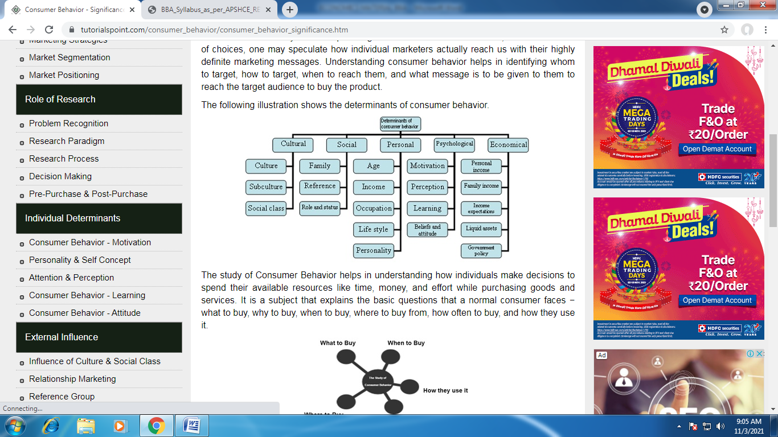
The study of Consumer Behavior helps in understanding how individuals make decisions to spend their available resources like time, money, and effort while purchasing goods and services. It is a subject that explains the basic questions that a normal consumer faces − what to buy, why to buy, when to buy, where to buy from, how often to buy, and how they use it.
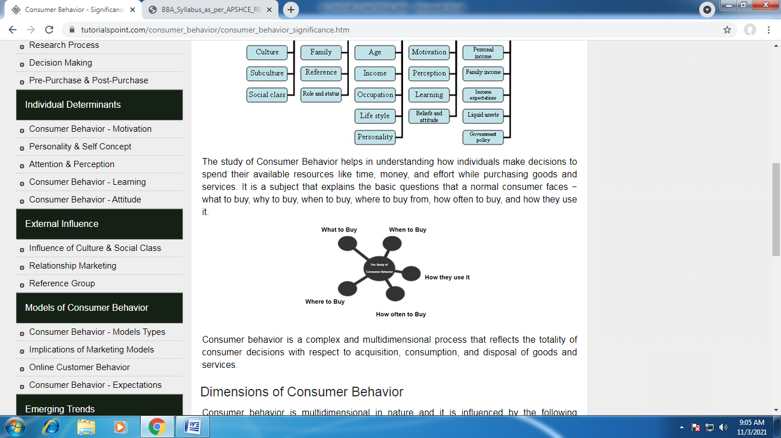
Consumer behavior is a complex and multidimensional process that reflects the totality of consumer decisions with respect to acquisition, consumption, and disposal of goods and services.

Dimensions of Consumer Behavior
- Psychology is a discipline that deals with the study of mind and behavior. It helps in understanding individuals and groups by establishing general principles and researching specific cases. Psychology plays a vital role in understanding how consumers behave while making a purchase.
- Sociology is the study of groups. When individuals form groups, their actions are sometimes relatively different from the actions of those individuals when they are operating individually.
- Social Psychology is a combination of sociology and psychology. It explains how an individual operates in a group. Group dynamics play an important role in purchasing decisions. Opinions of peers, reference groups, their families and opinion leaders influence individuals in their behavior.
- Cultural Anthropology is the study of human beings in society. It explores the development of central beliefs, values and customs that individuals inherit from their parents, which influence their purchasing patterns.

Consumer Behavior - Demand Analysis

It must be remembered that demand in Economics is always stated with reference to a particular price. Any change in price will normally bring about a change in the quantity demanded. In addition to price, demand is also used in reference to a particular period of time.

The demand arises out of the following three things:
- Desire or want of the commodity.
- Ability to pay,
- Willingness to pay.

Definitions:
“Demand for a commodity is the quantity which a consumer is willing to buy at a particular price at a particular time.”

A consumer’s demand for a commodity is influenced by the following factors:
1. A consumer’s demand for a commodity is influenced by the price of that commodity. Usually the higher the price, the lower will be the quantity demanded.
2. A consumer’s demand for a commodity is influenced by the size of his income. In most cases, the larger the income, the greater will be the quantity demanded.
3. A consumer’s demand for a commodity is influenced by the prices of related commodities. They may be complementary or substitutes.
4. The tastes of the consumers.

Determinants of Demand
The key determinants that affect the demand function are as follows −
- Income − A rise in consumer’s income will tend to increase the demand curve (shift the demand curve to the right). A fall will tend to decrease the demand for normal goods.
- Consumer Preferences − Favorable change leads to an increase in demand, unfavorable change leads to a decrease in demand.
- Number of Buyers − More the number of buyers, more will be the demand. Fewer buyers lead to a decrease in demand.
- Substitute Goods (goods that can be used to replace each other) − The price of substitutes and demand for the other good are directly related. Example − If the price of coffee rises, the demand for tea will also rise.
- Complementary Goods (goods that can be used together) − The prices of complementary goods and their demand are inversely related. Example − if the price of printer increases, the demand for computer sheets will decrease.

Demand Function
The demand function relates to the price and quantity. It shows how many units of a good will be purchased at different prices. At higher prices, less quantity will be purchased.
The graphical representation of the demand function has a negative (-ve) slope. The market demand function is calculated by totaling up all of the individual demand functions.

Demand Function of an Individual
The individual demand function has a functional relationship between individual demand and the factors affecting individual demand.
It is expressed as −
D_{x} = f (P_{x}, P_{r}, Y, T, F)
Where,
D_{x} = Commodity Demand x;
P_{x} = Commodity x”s price;
P_{r} = Related Goods’ Price;
F = Expectation of Change in Price in future.
Y = Consumer’s Income;
T = Tastes and Preferences.

Notes in the Factors Determining Individual Demand:
Demand is not dependent on price alone. There are many other factors which affect the demand of a product.

Notes on the Factors Determining Market Demand:
Market demand for a commodity means the sum total of the demand of all individuals. Market demand depends, not only on the prices of the commodity and prices of related commodities but also on the number of factors.

These are:
1. Pattern of Income Distribution:
If National income is equitably distributed, there will be more demand and vice-versa. If income distribution moves in favour of downtrodden people, then demand for such commodities, which are used by common people would increase. On the other hand, if the major part of National income is concentrated in the hands of only some rich people, the demand for luxury goods will increase.
2. Demographic Structure:
Market demand is influenced by change in size and composition of population. Increase in population leads to more demand for all types of goods and decrease in population means less demand for them. Composition of population also affects its demand. Composition refers to the number of children, adults, males, females etc., in the population.
When the composition changes, for example, when the number of females exceeds to that of the males, then there will be more demand for goods required by women folk.
3. Government Policy:
Government policy of a country can also affect the demand for a particular commodity or commodities through taxation. Reduction in the taxes and duties will allow more persons to enter a particular market and thus raising the demand for a particular product.
4. Season and Weather:
Demands for commodities also depend upon the climate of an area and weather. In cold hilly areas woolens are demanded. During summer and rainy season demand for umbrellas may rise. In winter ice is not so much demanded.
5. State of Business:
The levels of demand in a market for different goods depend upon the business condition of the country. If the country is passing through boom, the trade is active and brisk. The demand for all commodities tends to rise. But in the days of depression, when trade is dull and slow, demand tends to fall.

Demand Schedule:
The demand schedule in economics is a table of quantity demanded of a good at different price levels. Given the price level, it is easy to determine the expected quantity demanded. This demand schedule can be graphed as a continuous demand curve on a chart where the Y-axis represents price and the X-axis represents the quantity.

The demand schedule can be classified into two categories:
- Individual demand schedule;
- Market demand schedule.

1. Individual Demand Schedule:
It represents the demand of an individual’ for a commodity at different prices at a particular time period. The adjoining table 7.1 shows a demand schedule for oranges on 7th July, 2009.
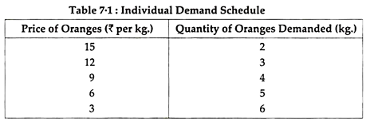

2. Market Demand Schedule:
Market Demand Schedule is defined as the quantities of a given commodity which all consumers will buy at all possible prices at given moment of time. In a market, there are several consumers, and each has a different liking, taste, preference and income. Every consumer has a different demand.
The market demand actually represents the demand of all the consumers combined together. When a particular commodity has several brands or types of commodities, the market demand schedule becomes very complicated because of various factors.

However, for a single item, the market demand schedule is rather simple. Study the market demand schedule for milk in table 7.2.
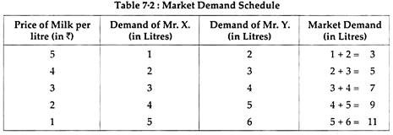

Demand Curves (Diagram):
The demand curve is a graphic statement or presentation of the relationship between product price and the quantity of the product demanded. It is drawn with price on the vertical axis of the graph and quantity demanded on the horizontal axis.
Demand curve does not tell us the price. It only tells us how much quantity of goods would be purchased by the consumer at various possible prices.

Depending upon the demand schedule, the demand curve can be as follows:
- Individual Demand Curve
- Market Demand Curve

1. Individual Demand Curve:
An Individual Demand Curve is a graphical representation of the quantities of a commodity that an individual (a particular consumer) stands ready to take off the market at a given instant of time against different prices. In Fig. 7.1, an Individual Demand Curve is drawn on the basis of Individual Demand Schedule given above in table 7.1.
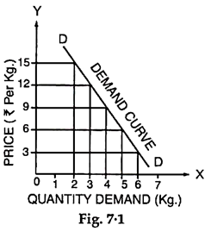
2. Market Demand Curve:
A Market Demand Curve is a graphical representation of the quantities of a commodity which all the buyers in the market stand ready to take off at all possible prices at a given moment of time. In Figure 7.2 a Market Demand Curve is drawn on the basis of Market Demand Schedule given in Table 7.2.
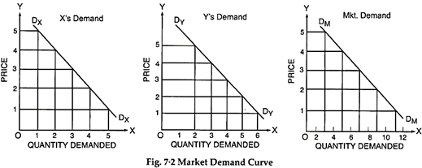
Both, the individual consumer’s demand curve is a straight line. A demand curve will slope downward to the right.
It is not necessary, that the demand curve is a straight line. A demand curve may be a convex curve or a concave curve. It may take any shape provided it is negatively sloped.
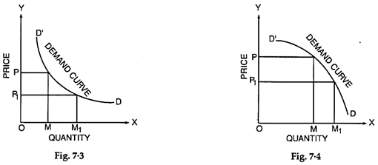

Notes on Law of Demand:
The law of demand expresses functional relationship between price and the quantity. It has been universally observed that people buy more quantity of goods when, they are available at a lower price and the quantity purchased declines with an increase in its price.
“A rise in the price of a commodity or service is followed by a fall in quantity demanded, and a fall in price is followed by an increase in quantity demanded”. Thus, lower the price, the larger is the quantity demanded of a commodity and vice-versa.
The law thus, states that other things being equal the quantity demanded varies inversely with price. Lower the price, greater is the effective demand; higher the price; lesser is the effective demand.

Characteristics of Law of Demand: The law of demand has three specific characteristics:

- General Tendency,
- Relation to Time, and
- Price and Demand Relationship.

1. General Tendency:
The law simply indicates a general tendency of changes in quantity demanded with the changes in prices. However, it does not mention any specific propositions of changes in quantity demanded with changes in prices.

2. Relation to Time:
The law of demand is always related to time, because the price changes from time to time and these are never fixed. Thus, the co-relation between the prices and the quantities demanded should be considered for a specific time or at particular instant.

3. Price and Demand Relationship:
The increase or decrease in the prices does affect the quantity demanded at a particular time. Thus, the change in the quantity demanded cannot be considered without change in prices. It must, therefore, be noted that the relationship between price and quantity demanded is relative.

Assumptions of Law of Demand:
  - The income of the consumer remains same during the period under consideration.
  - The prices of related goods remain unchanged during the period.
  - The preferences and tastes of consumers must remain the same during the period of consumption.
  - The quality of similar goods available in the market is almost unchanged.
  - During the period under study, it is presumed that prices are not likely to change in near future.
  - No substitutes for the commodity in question are available.

Exceptions to the Law of Demand:
There are certain exceptions to the law of demand. It means that under certain circumstances, consumers buy more when the price of a commodity rises and less when the price falls. In such case the demand curve slopes upward from left to right i.e. demand curve has a positive slope as is shown in Fig. 7.5. Many causes can be attributed to an upward sloping demand curve.
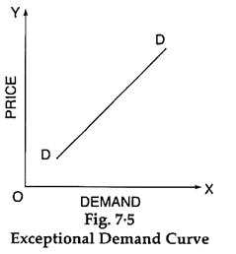
1. Ignorance:
Sometimes consumers are fascinated with the high priced goods from the idea of getting a superior quality. However, this may not be always true. Superior/deceptive packing and high price deceive the people. This can be called as ‘Ignorance effect’.
2. Speculative Effect:
When the price of a commodity goes up, people may buy larger quantity than before, if they anticipate or speculate a further rise in its price. On the other hand, when the price falls, people may not react immediately and may still purchase the same quantity as before, waiting for another fall in the price. In both the cases, the law of demand fails to operate. This is known as speculative effect.
3. The Giffen Effect:
A fall in the price of inferior goods (Giffen Goods) tends to reduce its demand and a rise in its price tends to extend its demand. This phenomenon was first observed by SIR ROBERT GIFFEN, popularly known as Giffen effect.
He observed that the working class families of U.K. were compelled to curtail their consumption of meat in order to be able to spend more on bread Mr. Giffen, British economist, observed that rise in the price of bread caused the low paid British workers to buy more bread.
These workers lived mainly on the diet of bread, when price rose, as they had to spend more for a given quantity of bread, they could not buy as much meat as before. Bread still being comparatively cheaper was substituted for meat even at its high price.
4. Fear of Shortage:
People may buy more of a commodity even at higher prices when they fear of a shortage of that commodity in near future. This is contrary to the law of demand. It may happen during times of war and inflation and mostly in the case of goods which fall in the category of necessities of life like sugar, kerosene oil, etc.
5. Prestigious Goods:
If consumers measure the desirability of a good entirely by its price and not by its use, then they buy more of a good at high price and less of a good at low price, Diamond, Jewellery and big cars etc., are such prestigious goods. In their case demand relates to consumers who use them as status symbol.
As their prices go up and become costlier, rich people think it is more prestigious to have them. So they purchase more. On the other hand, when their prices fall sharply, they buy less, as they are no more prestigious goods. This is known as (Veblen effect) or (Demonstration effect).
6. Conspicuous Necessities:
Another exception occurs in use of such commodities as due to their constant use, have become necessities of life. For example, inspite of the fact that the prices of television sets, refrigerators, washing machines, cooking gas, scooters, etc., have been continuously rising, their demand does not show any tendency to fall. More or less same tendency can be observed in case of most of other commodities that can be termed as ‘Upper-Sector Goods’.
7. Bandwagon Effect:
The consumer’s demand for a good may be affected by the tastes & preferences of the social class to which he belongs. If purchasing diamond becomes fashionable, then, as the price of diamond rises, rich people may increase their demand for diamonds in order to show that they are rich.
8. Snob Effect:
People sometimes buy certain commodities like diamonds at high prices not due to their intrinsic worth but for a different reason. The basic object is to display their riches to the other members of the community to which they themselves belong. This is known as Snob appeal.

Movement along a Demand Curve and Shifts in the Demand Curve (Diagrams):
1. Change in Quantity Demanded — Movement along a Demand Curve:
Extension and Contraction of Demand- The quantity demanded of a product does not remain constant, but keeps on changing due to various factors. If the quantity demanded changes due to change in price only, it is called expansion and contraction of demand. If price decreases, it results in expansion of demand and if price increases it results in contraction of demand. This situation is shown by movement along the same demand curve.
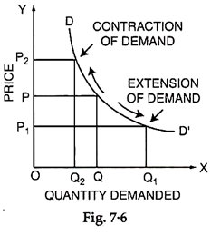
In figure 7.6, we have shown expansion and contraction of demand. At price OP, quantity demanded is OQ. If price reduces to OP₁, the quantity demanded increase to OQ₁. This increase of quantity demanded would be called expansion of demand. If, however, price increases from OP to OP₂, then quantity demanded decrease in equality would be called contraction of demand.
2. Change in Demand— Shifts in the Demand Curve: Increase and Decrease of Demand:
If the change in quantity demanded of a product takes place due to any factor, other than price of the product, then it is called increase or decrease of demand. This phenomenon is shown by a shift in the entire demand curve. For example- if the income of the consumer rises then his entire demand curve shifts to right which shows that consumer’s demand for the product has increased for every given price.
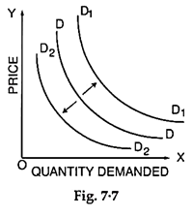
In the figure 7.7 we can say if demand increases due to increase in income then demand curve shifts to right from DD to D₁D₁. If, however, the demand decreases due to fall in income then the demand curve shifts to left from DD to D₂D₂.

Kinds of Demand:
The demands can be classified as:
- Price Demand
- Income Demand
- Cross Demand
1. Price Demand:
The price demand refers to various quantities of a commodity or services that are purchased at a given time and at given prices from the market. However, in such studies, the consumer’s taste, his income, habit and prices of related goods are assumed to be unchanged. Price demand has inverse relation with the price i.e., if the price of a commodity increases, its demand decreases and as the price decreases, its demand increases.
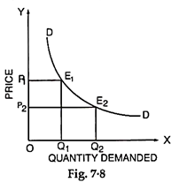
It can be seen in Fig. 7.8, when the price of the commodity was OP₁, the quantity demanded was OQ₁. When the price reduced to OP₂, the quantity demanded increased to OQ₂. Hence the price and the quantity demanded of a commodity show an inverse relationship.
2. Income Demand:
The income demand refers to the various quantities of a commodity or service purchased by the consumers at different income levels. It is assumed that the price of commodity, price of related goods and consumers’ tastes do not change. Under such conditions, with the increase in income, a consumer may purchase increased quantity of the commodity even though there may not be any fall in price.
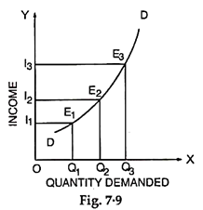
Fig. 7.9 exhibits the direct relationship between income of a consumer and demand of a commodity. As can be seen in the figure that as the income of the consumer increases from OI₁ to OI₂, the demand of the commodity increases from OQ₁ to OQ₂. Similarly when the income increases from OI₂ to OI₃, the demand of the commodity raises from OQ₂ to OQ₃.

3. Cross Demand:
Cross demand refers to the quantity of a commodity which would be demanded as a consequence of changes in price of related complementary or substitute goods.

(i) In the Case of Substitutes:
A rise in the price of good y (say Coffee) raises the demand for good x (Say Tea), similarly, a fall in the price of y, (Coffee) the demand for x (Tea) falls. Fig. 7.10. illustrates it.
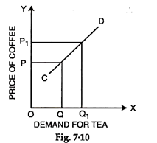
When the price of good y (Coffee) increases from OP to OP₁ the quantity of good x (Tea) also increases from OQ to OQ₁. The cross demand curve CD for substitutes is positively sloping.
(ii) In the Case of Complementary:
In case of complementary goods such as pant and shirt, pen and ink, car and petrol, etc., a fall in the price of one good y (Say car) will raise the demand for good x (Say petrol). Conversely a rise in the price of y (Car) will bring a fall in the demand for x (Petrol). This is illustrated in Fig. 7.11.
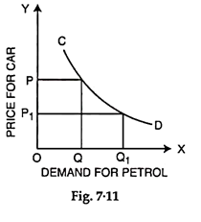
When the price of y (Car) falls from OP to OP₁, the demand for x (Petrol) increases from OQ to OQ₁. The cross demand curve in case of complementary goods CD is negatively sloping.

Inter-Related Demands:
It has been assumed that demand of a particular commodity is quite independent of demand for other goods. But in actual life, most of the demands are closely inter-related.

From a practical point of view, the inter-related demands can be classified as:
1. Joint Demand
2. Direct Demand and Derived Demand
3. Composite Demand
1. Joint Demand:
When several items are demanded for one particular purpose such demand is known as Joint Demand. Demand for complementary goods is also known as Joint Demand. For example, for fabrication of furniture, the items required are wood, nails, varnish, etc.
Thus, whenever the demand of furniture increases, the demand of wood, nails, etc., also increases. This is called a Joint Demand. Similarly, for the construction of the houses, the demand for bricks, cement, masons, labourers, etc., will constitute a Joint Demand.

The Joint Demand for coffee is denoted by the given line diagram (Fig. 7.12).
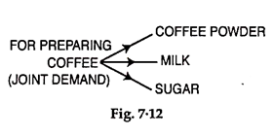
2. Direct Demand and Derived Demand:
Whenever several items are required to make a particular commodity, the demand for various commodities is termed as the Derived Demand and demand of ultimate commodity is called as Direct Demand. For example, the demand for building is a direct demand and demands for cement, bricks, sand, timber, etc., are called as derived demands. It is denoted by the given line diagram (Fig. 7.13).
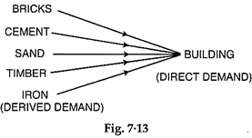
3. Composite Demand:
A commodity can be used for several purposes and its demand is directly linked to its sweets various uses such a demand is known as Composite Demand. For example, milk is used for making tea, coffee, butter, cheese, curd, sweets and for direct consumption. The total demand of milk in the market is for all such purposes and it is called composite demand, denoted by the given line diagram (Fig. 7.14).
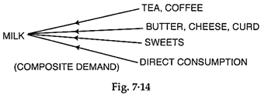

Elasticity of Demand

Elasticity of demand is an important variation on the concept of demand. Demand can be classified as elastic, inelastic or unitary.

An elastic demand is one in which the change in quantity demanded due to a change in price is large. An inelastic demand is one in which the change in quantity demanded due to a change in price is small.

Elasticity of Demand
Elasticity of Demand, or Demand Elasticity, is the measure of change in quantity demanded of a product in response to a change in any of the market variables, like price, income etc. It measures the shift in demand when other economic factors change.

In other words, the elasticity of demand is the percentage change in quantity demanded divided by the percentage change in another economic variable.
The demand for a commodity is affected by different economic variables:

- Price of the commodity
- Price of related commodities
- Income level of consumers

Types of Elasticity of Demand :- 3 types
On the basis of different factors affecting the quantity demanded for a product, elasticity of demand is categorized into mainly three categories: Price Elasticity of Demand (PED), Cross Elasticity of Demand (XED), and Income Elasticity of Demand (YED).
1. Price Elasticity of Demand (PED)
Any change in the price of a commodity, whether it’s a decrease or increase, affects the quantity demanded for a product. For example, when there is a rise in the prices of ceiling fans, the quantity demanded goes down.

This measure of responsiveness of quantity demanded when there is a change in price is termed as the Price Elasticity of Demand (PED).

The mathematical formula given to calculate the Price Elasticity of Demand is:
PED = % Change in Quantity Demanded % / Change in Price

The result obtained from this formula determines the intensity of the effect of price change on the quantity demanded for a commodity.

2. Income Elasticity of Demand (YED)
The income levels of consumers play an important role in the quantity demanded for a product. This can be understood by looking at the difference in goods sold in the rural markets versus the goods sold in metro cities.

The Income Elasticity of Demand, also represented by YED, refers to the sensitivity of quantity demanded for a certain good to a change in real income (the income earned by an individual after accounting for inflation) of the consumers who buy this good, keeping all other things constant.

The formula given to calculate the Income Elasticity of Demand is given as:

SYED = % Change in Quantity Demanded% / Change in Income

The result obtained from this formula helps to determine whether a good is a necessity good or a luxury good.

3. Cross Elasticity of Demand (XED)
In a market where there is an oligopoly, multiple players compete. Thus, the quantity demanded for a product does not only depend on itself but rather, there is an effect even when prices of other goods change.

Cross Elasticity of Demand, also represented as XED, is an economic concept that measures the sensitiveness of quantity demanded of one good (X) when there is a change in the price of another good (Y), and that’s why it is also referred to as Cross-Price Elasticity of Demand.

The formula given to calculate the Cross Elasticity of Demand is given as:

XED = (% Change in Quantity Demanded for one good (X)%) / (Change in Price of another Good (Y))

The result obtained for a substitute good would always come out to be positive as whenever there is a rise in the price of a good, the demand for its substitute rises. Whereas, the result will be negative for a complementary good.

5 other types of Elasticity of Demand

The effect of change in economic variables is not always the same on the quantity demanded for a product.

The demand for a product can be elastic, inelastic, or unitary, depending on the rate of change in the demand with respect to the change in the price of a product.

On the basis of the amount of fluctuation shown in the quantity demanded of a good, it is termed as ‘elastic’, ‘inelastic’, and ‘unitary’.

- An elastic demand is one that shows a larger fluctuation in the quantity demanded of a product, in response to even a little change in another economic variable. For example, if there is a hike of $0.5 in the price of a cup of coffee, there are very high chances of a steep decline in the quantity demanded.

- An inelastic demand is one that shows a very little fluctuation in the quantity demanded with respect to a change in another economic variable. An example of this can be petrol or diesel.

- Unitary elasticity is one in which the fluctuation in one variable and quantity demanded is equal.

We can further classify these elastic and inelastic types of demand into five categories.

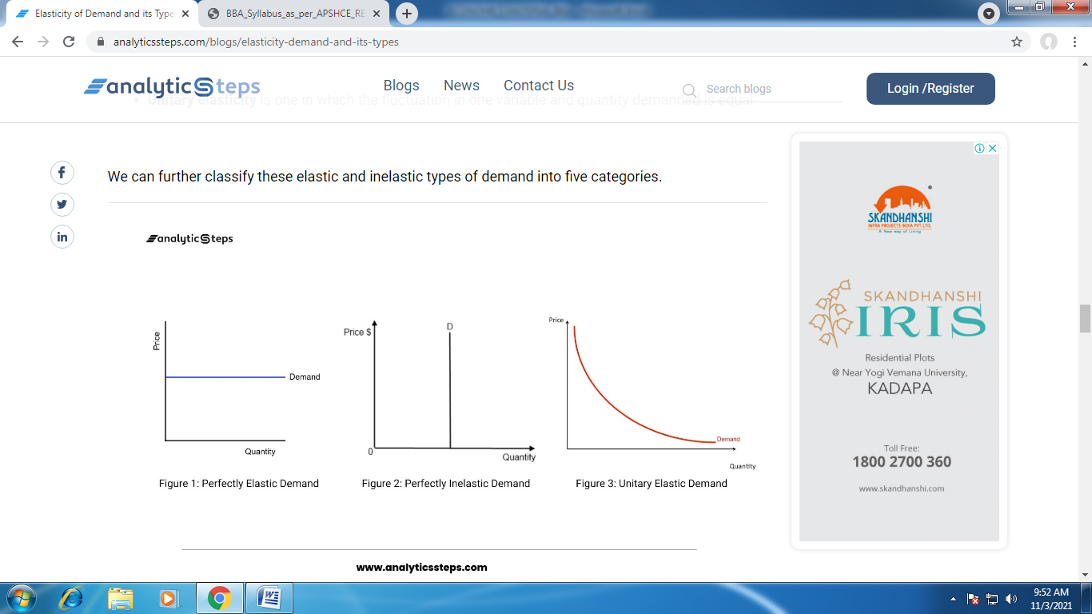

1. Perfectly Elastic Demand

When there is a sharp rise or fall due to a change in the price of the commodity, it is said to be perfectly elastic demand. In perfectly elastic demand, even a small rise in price can result in a fall in demand of the good to zero, whereas a small decline in the price can increase the demand to infinity.

However, perfectly elastic demand is a total theoretical concept and doesn’t find a real application, unless the market is perfectly competitive and the product is homogenous.

The degree of elasticity of demand helps to define the slope and shape of the demand curve. Therefore, we can determine the elasticity of demand by looking at the slope of the demand curve. A Flatter curve will represent a higher elastic demand. Thus, the slope of the demand curve for a perfectly elastic demand is horizontal.

2. Perfectly Inelastic Demand

A perfectly inelastic demand is the one in which there is no change measured against a price change. Like perfectly elastic demand, the concept of perfectly inelastic is also a theoretical concept and doesn’t find a practical application. However, the demand for necessity goods can be the closest example of perfectly inelastic demand.

The numerical value obtained from the PED formula comes out as zero for a perfectly inelastic demand.
The demand curve for a perfectly inelastic demand is a vertical line i.e. the slope of the curve is zero.

3. Relatively Elastic Demand

Relatively elastic demand refers to the demand when the proportionate change in the demand is greater than the proportionate change in the price of the good. The numerical value of relatively elastic demand ranges between one to infinity.

In relatively elastic demand, if the price of a good increases by 25% then the demand for the product will necessarily fall by more than 25%.

Unlike the aforementioned types of demand, relatively elastic demand has a practical application as many goods respond in the same manner when there is a price change.

The demand curve of relatively elastic demand is gradually sloping.
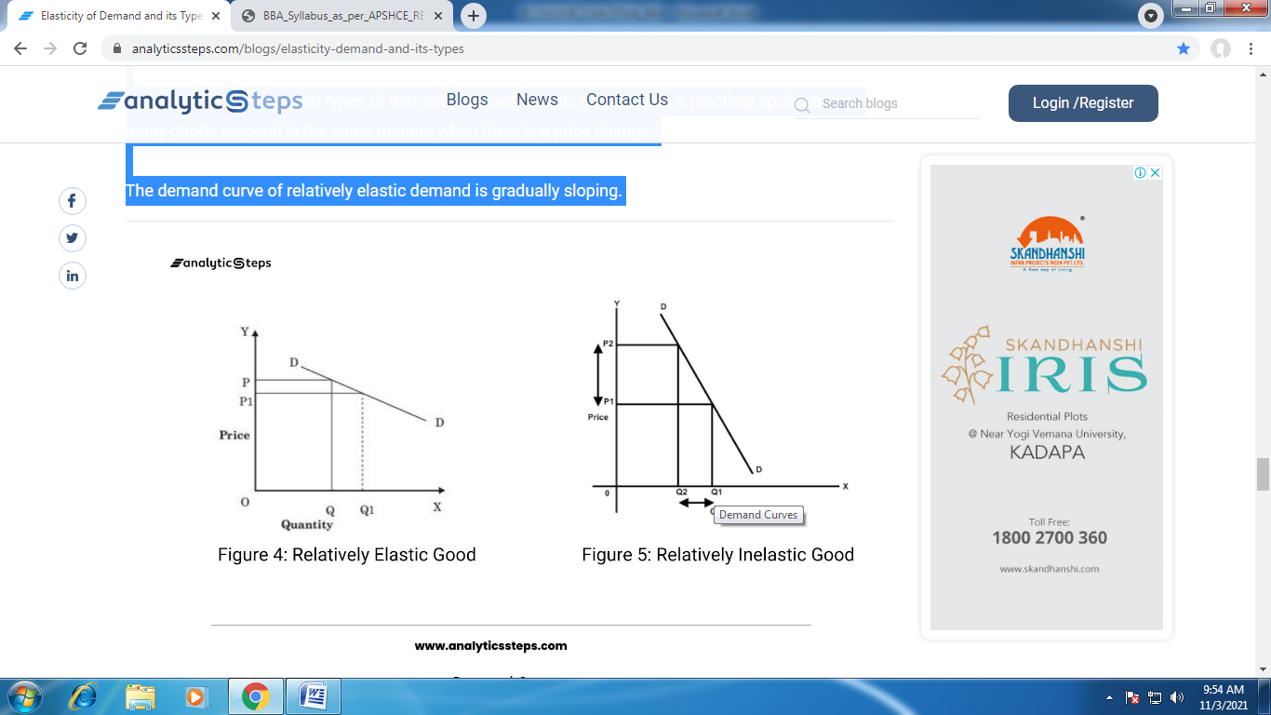

4. Relatively Inelastic Demand
In a relatively inelastic demand, the proportionate change in the quantity demanded for a product is always less than the proportionate change in the price.

For example, if the price of a good goes down by 10%, the proportionate change in its demand will not go beyond 9.9..%, if it reaches 10% then it would be called unitary elastic demand.
The numerical value of relatively inelastic demand always comes out as less than 1 and the demand curve is rapidly sloping for such type of demand.

5. Unitary Elastic Demand

When the proportionate change in the quantity demanded for a product is equal to the proportionate change in the price of the commodity, it is said to be unitary elastic demand.

UNIT – III

A customer is the one who usually determines his demand for goods on the basis of the satisfaction (utility) that he procures from them. So, what is a utility?
Utility of goods is their want-satisfying capability. More is the aspiration to have the goods, the more is the utility procured from them. Utility is instinctive. Distinct people can get different degrees of utility from the same goods. For instance, someone who likes sweets will get much higher utility from a sweet than someone who doesn’t like sweets.
The utility that an individual obtains from the goods can differ with the change in location and time. For instance, utility from the use of an air conditioner certainly relies upon whether the person is in Srinagar or Jaipur (location) or whether it is winter or summer (season).

Relationship between Want, Utility, Consumption and Satisfaction

Want of the consumer is the basis of understanding her behaviour. A consumer selects a commodity based on its want satisfying power. Consumption of the commodity leads to satisfaction of wants. Thus want, utility, consumption and satisfaction are related in following manner:
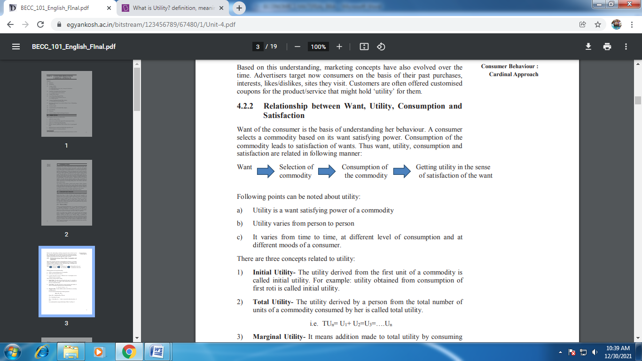

Approaches that elucidate consumer behaviour
Following points can be noted about utility:
- Utility is a want satisfying power of a commodity
- Utility varies from person to person
- It varies from time to time, at different level of consumption and at different moods of a consumer.
Measures of utility
- Initial Utility- The utility derived from the first unit of a commodity is called initial utility. For example: utility obtained from consumption of first roti is called initial utility.
- Total utility: Total utility of a determined quantity of goods or commodities (TU) is the total contentment procured from utilising the given amount of some goods ‘p’.
- Marginal utility: MU is the difference in total utility due to the utilisation of one extra unit of goods or commodities.
- Ordinal utility analysis: The customer does not quantify utility in numerals. The theory of customer decision-making under constraints of certitude can be, and mostly is, conveyed in terms of ordinal utility.

CARDINAL UTILITY ANALYSIS:
Cardinal utility Analysis was mainly given by neoclassical economists like Jevons, Dupuit, Menger, Walras and Pigou etc. The exponents of this approach regards utility as cardinal concept. In other words, they hold that utility is a measurable and quantifiable entity. For example, According to cardinal utility approach, if a person is drinking a glass of water, it will be possible for him to assign some numerical value say 10 utils or 20 utils to the utility derived from it.

This approach is based on following assumptions:
- The cardinal measurement of utility- Utility of any commodity can be measured in units called ‘utils’.
- Utilities are additive i.e. total utility can be calculated by measuring utility derived from all the units of a commodity consumed.
- Utility is independent i.e. not related to the amounts of other commodities purchased by the consumer. Further, it is also assumed that it is not affected by utilities of other individuals.
- Marginal utility of money remains constant: When a person purchases more of a good, the amount of money diminishes and marginal utility of remaining money may increase. But in this approach, marginal utility of money is treated constant. This assumption is important as cardinalists have used money as a measure of utility and it is necessary to keep the measuring rod of utility as fixed

Marginal Utility Analysis
Marginal utility analysis focuses on understanding the consumer’s behaviour in allocating his expenditure on different goods and services for the maximum utilization of the available resources. To delve more into the topic, let us first understand the marginal utility analysis definition.

What is Marginal Utility Analysis
To understand the concept of the marginal utility analysis, we need to focus on the following two points.
- Total utility refers to the sum of all the marginal utilities associated with different units of any commodity utilized by the consumer. Total utility is also known as full satiety.
- Marginal utility refers to the utility related to any additional component of the commodity. Individual marginal utility contributes to the total utility.

Assumptions of Marginal Utility Analysis
There are certain assumptions of marginal utility analysis.
- Cardinal Measurability
Marginal utility is considered to be a cardinal concept, i.e., it is quantifiable and measurable. If you derive different utilities from consuming variable units of separate commodities, then you can compare the commodities and select the one which provides better satisfaction and rate of utility. The theory also considers money as the means to measure utility. The utility derived from a given commodity is the amount spent on that commodity instead of going against it.
- Constant Nature of Marginal Utility
To facilitate marginal utility analysis on a particular commodity in the terms of money, it is important to assume that the marginal utility remains constant.

- Independent Utility Hypothesis
The independent utility hypothesis considers that the total utility is the sum of all the separate utilities of each commodity. It does not take into consideration the complementarity that exists between different commodities.

Diminishing Marginal Utility Law
The diminishing marginal utility law is an important law of marginal utility analysis. The British economist Alfred Marshall puts forward the diminishing marginal utility analysis definition as the additional profit, associated with an increase in the stock of a commodity, decreases with the increase. Such a law was based on the human nature of unlimited demands. As more and more units are consumed, the intensity of our desire decreases to a point when we no longer desire it.
Therefore, the extra benefits associated with the consumption of surplus units of any product decreases as the consumption of the product increases. However, it must be kept in mind that although the marginal utility decreases with increasing stock, the total utility does not decrease.

Correlation Between Total Utility and Marginal Utility
If you have understood what is marginal utility analysis, then you will be able to denote the correlation between total utility and marginal utility. The following points will define such a relationship.
- The total utility can rise although if the marginal utility decreases.
- If the total utility has reached the maximum value, marginal utility is equal to zero.
- If the total utility decreases, the marginal utility value tends to be negative.

Limitations of the Law of Diminishing Marginal Utility
There are certain limitations to the law. It is based on certain assumptions as follows.
- Homogeneous Units: The different units of products and the attributes of the consumer like temperament, taste, income, etc. are identical at all times.
- Standard Consumption Units: The consumption units are considered to be standard units. For example, the unit for water consumption will always be a glass.
- Continuous Consumption: The consumers continuously consume the units of the product without any gap in between.
- The Law cannot be applied to Prestigious Goods: The law does not take prestigious goods into consideration since the increase in stock increases the demands.
- Related Goods: The utility of any product is related to the presence or absence of a related product. For example, your tea consumption can be less in the absence of sugar.

Law Of Equi-Marginal Utility
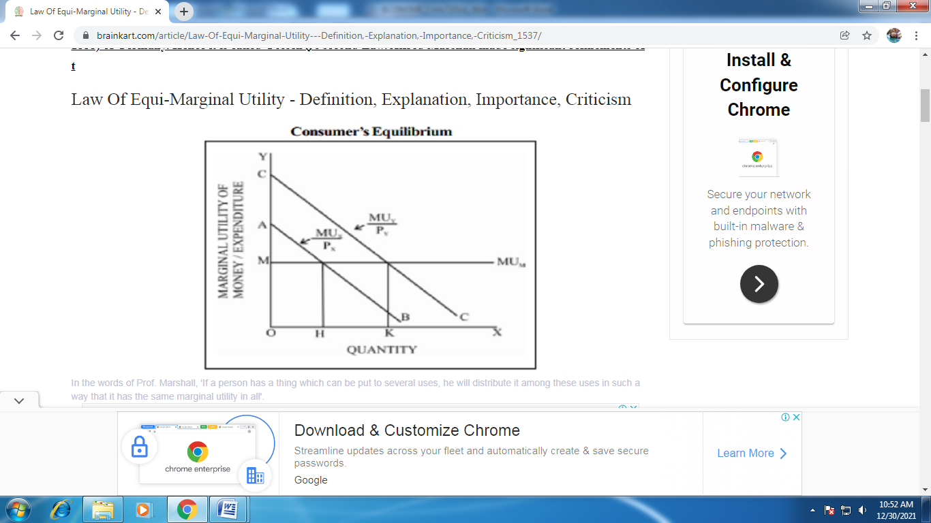
The idea of equi-marginal principle was first mentioned by H.H.Gossen (1810-1858) of Germany. Hence it is called Gossen's second Law. Alfred Marshall made significant refinements of this law in his 'Principles of Economics'.

The law of equi-marginal utility explains the behaviour of a consumer when he consumers more than one commodity. Wants are unlimited but the income which is available to the consumers to satisfy all his wants is limited. This law explains how the consumer spends his limited income on various commodities to get maximum satisfaction. The law of equi-marginal utility is also known as the law of substitution or the law of maximum satisfaction or the principle of proportionality between prices and marginal utility.
In the words of Prof. Marshall, 'If a person has a thing which can be put to several uses, he will distribute it among these uses in such a way that it has the same marginal utility in all'.
Assumptions
  - The consumer is rational so he wants to get maximum satisfaction.
  - The utility of each commodity is measurable.
  - The marginal utility of money remains constant.
  - The income of the consumer is given.
  - The prices of the commodities are given.
  - The law is based on the law of diminishing marginal utility.

Explanation of the law
Suppose there are two goods X and Y on which a consumer has to spend a given income. The consumer being rational, he will try to spend his limited income on goods X and Y to maximise his total utility or satisfaction. Only at that point the consumer will be in equilibrium.
According to the law of equi-marginal utility, the consumer will be in equilibrium at the point where the utility derived from the last rupee spent on each is equal.


Limitations of the Law
The law of equi-marginal utility bristles with the following difficulties.
1. Indivisibility of Goods
The theory is weakened by the fact that many commodities like a car, a house etc. are indivisible. In the case of indivisible goods, the law is not applicable.
2. The Marginal Utility of Money is Not Constant
The theory is based on the assumption that the marginal utility of money is constant. But that is not really so.
3. The Measurement of Utility is not Possible
Marshall states that the price a consumer is willing to pay for a commodity is equal to its marginal utility. But modern economists argue that, if two persons are paying an equal price for given commodity, it does not mean that both are getting the same level of utility. Thus utility is a subjective concept, which cannot be measured, in quantitative terms.

4. Utilities are Interdependent
This law assumes that commodities are independent and therefore their marginal utilities are also independent. But in real life commodities are either substitutes or complements. Their utilities are therefore interdependent.
5. Indefinite Budget Period
According to Prof. K.E. Boulding, indefinite budget period is another difficulty in the law. Normally the budget period is assumed to be a year. But there are certain commodities which are available in several succeeding accounting periods. It is difficult to calculate marginal utility for such commodities.
Ordinal Utility
Definition: The Ordinal Utility approach is based on the fact that the utility of a commodity cannot be measured in absolute quantity, but however, it will be possible for a consumer to tell subjectively whether the commodity derives more or less or equal satisfaction when compared to another.
The modern economists have discarded the concept of cardinal utility and instead applied ordinal utility approach to study the behavior of the consumers. While the neo-classical economists believed that the utility can be measured and expressed in cardinal numbers, but the modern economists maintain that the utility being the psychological phenomena cannot be measured theoretically, quantitatively and even cardinally
The modern economist, Hicks, in particular, have applied the ordinal utility concept to study the consumer behavior. He introduced a tool of analysis called “Indifference Curve” to analyze the consumer behavior. An indifference curve refers to the locus of points each showing different combinations of two substitutes which yield the same level of satisfaction and utility to the consumer002E

Assumptions of Ordinal Utility Approach
- Rationality: It is assumed that the consumer is rational who aims at maximizing his level of satisfaction for given income and prices of goods and services, which he wish to consume. He is expected to take decisions consistent with this objective.
- Ordinal Utility: The indifference curve assumes that the utility can only be expressed ordinally. This means the consumer can only tell his order of preference for the given goods and services.
- Transitivity and Consistency of Choice: The consumer’s choice is expected to be either transitive or consistent. The transitivity of choice means, if the consumer prefers commodity X to Y and Y to Z, then he must prefer commodity X to Z. In other words, if X= Y, Y = Z, then he must treat X=Z. The consistency of choice means that if a consumer prefers commodity X to Y at one point of time, he will not prefer commodity Y to X in another period or even will not consider them as equal
- Nonsatiety: It is assumed that the consumer has not reached the saturation point of any commodity and hence, he prefers larger quantities of all commodities.
- Diminishing Marginal Rate of Substitution (MRS): The marginal rate of substitution refers to the rate at which the consumer is ready to substitute one commodity (A) for another commodity (B) in such a way that his total satisfaction remains unchanged. The MRS is denoted as DB/DA. The ordinal approach assumes that DB/DA goes on diminishing if the consumer continues to substitute A for B
Indifference Curve
Definition: The Indifference Curve shows the different combinations of two goods that give equal satisfaction and utility to the consumers. In other words, the indifference curve is the graphical representation of different combinations of goods (generally two), for which the consumers are indifferent, in terms of the overall satisfaction and the utility

Assumptions of Indifference Curve
- Only two goods are taken into the consideration. It is assumed that the customer has to make a choice between two goods, provided their prices remains constant.
- It is assumed that the customer is not saturated with both the commodities and look for more benefits from these two, to have a higher curve to have more satisfaction.
- The satisfaction level cannot be measured; thus, the customer ranks his preferences.
- It is assumed that the marginal rate of substitution diminishes, as more units of one good have to be set off by the reduction in the units of the other commodity. Thus, the indifference curve is convex to the origin.
- It is assumed that the consumer is rational and will make his choice objectively to have an increased utility and the satisfaction
The concept of Indifference curve can be further comprehended through an illustration below:
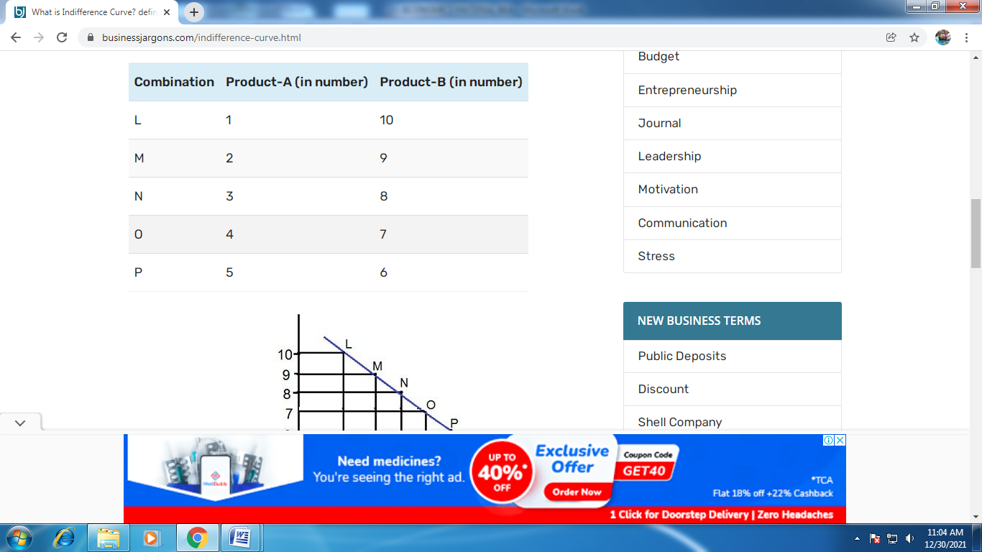

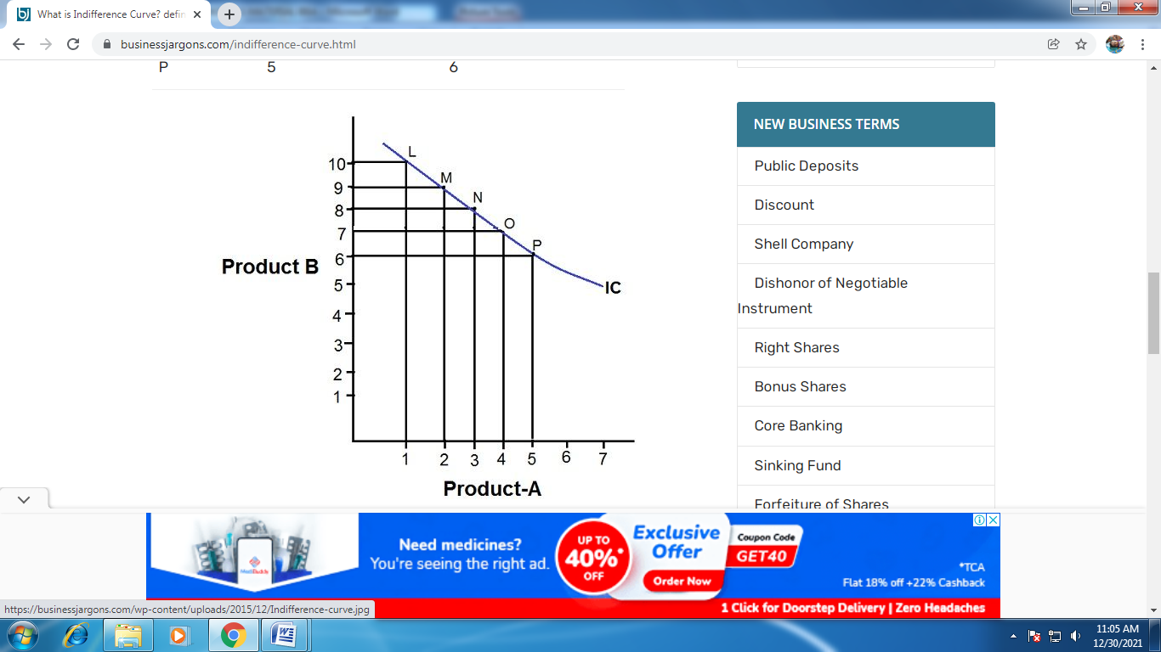

The consumer is indifferent between the Product-A and product-B, shown by 5 different combinations Viz. L, M, N, O, P. This means that combination L (10A+1B) gives an equal level of satisfaction and utility as (9A+ 2B), (7A+4B) and so on.. The IC curve shown in the figure above is generated by joining these combinations

Marginal Rate of Substitution
The Marginal Rate of Substitution can be defined as the rate at which a consumer is willing to forgo a number of units good X for one more of good Y at the same utility.
The marginal rate of substitution (MRS) is the rate at which some units of an item can be replaced by another while providing the same level of satisfaction to the consumer. The MRS concept describes the relationship between the consumption of two goods or resources when consumers make rational decisions.
- The marginal rate of substitution indicates the balance achieved between two desirable goods or resources without compromising the utility.
- MRS forms a part of the indifference curve theory, which measures how consumers react to different goods to get the same level of satisfaction.
- The formula for calculating the MRS = Change in good y/Change in good x
- Also, the graphical representation of the MRS involves drawing out an indifference curve involving the two products.
- The theory comes with limitations as the application is restricted to two commodities.
Marginal Rate of Substitute Formula = △Y/△X
where,
- △Y Change in Good Y
- △X Change in Good X
The MRS formula shows that when the number of substitutes grows in the subsequent phases and the number of current resources decreases, the MRS falls.
MRS representation in terms of marginal utility
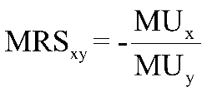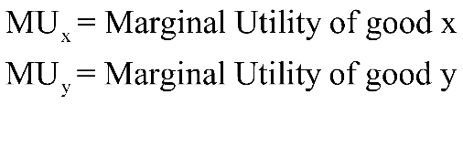
Calculation of MRS:
We can use the following steps to derive MRS.
MRS of good x for good y= change in good Y/change in good X
- X: Represents the substitute
- Y: Existing or current resource getting replaced

Diminishing Marginal Rate of Substitution
Under the diminishing rule, the increase in one resource gets balanced by a decrease in the other resource. For representing a diminishing MRS, assumptions portrayed are:
- The indifference curve never touches both axis of the graph
- Two indifference curves never intersect
- The indifference curve is downward slopping
- The indifference curve is convex to the origin indicating that MRS is diminishing
- The substitutes are never perfect substitutes or perfectly complementing in nature. Rather they should be normal goods with substitutable properties.
- We will not increase the number of both products simultaneously; rather, the changes in quantity will be in opposing directions.
Budget line and consumer equilibrium
The budget line, also known as the budget constraint, exhibits all the combinations of two commodities that a customer can manage to afford at the provided market prices and within the particular earning degree.
The budget line is a graphical delineation of all possible combinations of the two commodities that can be bought with provided income and cost so that the price of each of these combinations is equivalent to the monetary earnings of the customer.
It is important to keep in mind that the slope of the budget line is equivalent to the ratio of the cost of two commodities. The slope of the budget constraint possesses distinctive importance.
The two basic elements of a budget line are as follows:
- The consumer’s purchasing power (his/her income)
- The market value of both the products

Equation of a Budget Line
To understand the concept of a budget line in a detailed manner, it is important to understand the mentioned equation. The equation of the budget line equation can be represented as follows:
M = Px × Qx + Py × Qy
Where,
Px is the cost of product X.
Qx is the quantity of product X.
Py is the cost of product Y.
Qy is the quantity of product Y.
M is the consumer’s income.

Features of Budget Line
Some of the properties of the budget line are as follows:
- Negative slope: If the line is downward, it shows a reverse correlation between the two products.
- Straight line: It indicates a continuous market rate of exchange in individual combinations.
- Real income line: It denotes the income and the spending size of a customer.
- Tangent to indifference curve: It is the point when the indifference curve meets the budget line. This point is known as the consumer’s equilibrium.

Assumptions of a Budget Line
The budget line is mostly based on the assumption and not reality. However, to get clear and precise results and summary, the economist considers the following points in terms of a budget line:
- Two commodities: The economist assumes that the customers spend their income to purchase only two products.
- Income of the customers: The income of the customer is limited, and it is designated to buy only two products.
- Market price: The cost of each commodity is known to the customer.
- Expense is similar to income: It is assumed that the customer spends and consumes the whole income

A shift in Budget Line
A budget line includes a consumer’s earnings and the rate of a commodity. These are the two important factors that shift the budget line.
- Shift due to change in price: The amount of the product either increases or decreases from time to time. For instance, if the price and income of product A remains constant and the price of product B decreases, then the buying potential of product B automatically increases. Similarly, if the price of B increases and the other factors remain steady, the demand for product B automatically decreases.
- Shift due to change in income: Change in income makes a huge difference that leads to a change in the budget line. High income means high purchasing possibility and low income means low purchasing potential, making the budget line to shift.
It is also important to remember that the intercept OB on the Y-axis in Fig. 8.14 equals the amount of his entire income divided by the price of commodity Y. That is, OB = M/P_{y}. Likewise, the intercept OL on the X-axis measures the total income divided by the price of commodity X. Thus OL = M/V_{x}.
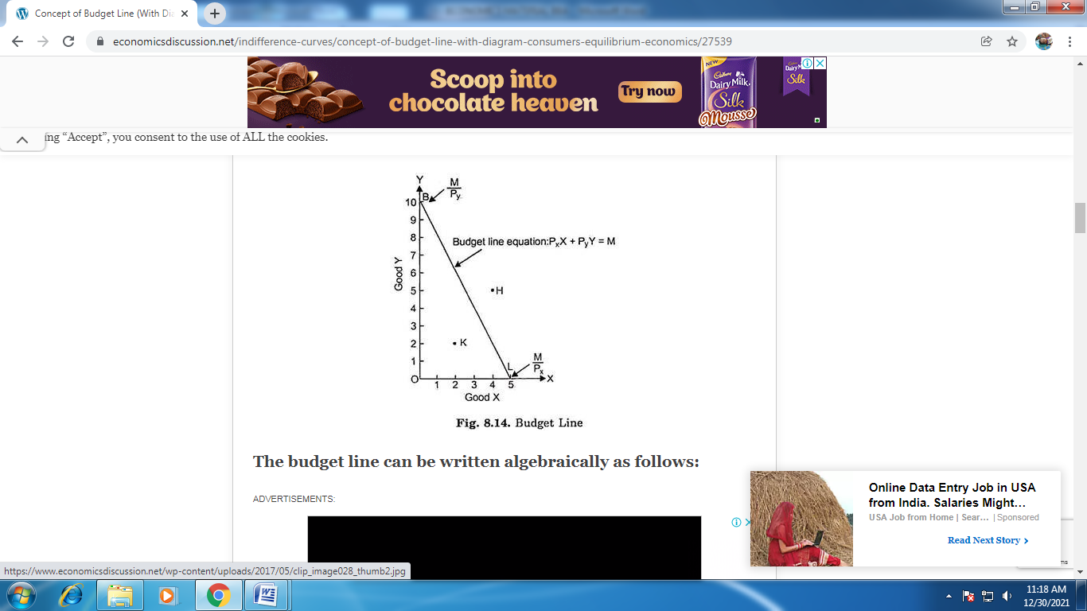
Slope of the Budget Line and Prices of two Goods:
It is also important to remember that the slope of the budget line is equal to the ratio of the prices of two goods. This can be proved with the aid of Fig. 8.14. Suppose the given income of the consumer is M and the given prices of goods X and Y are P_{x} and P_{y} respectively. The slope of the budget line BL is OB/OL. We intend to prove that slope OB/OL is equal to the ratio of the price of goods X and Y.
The quantity of good X purchased if whole of the given income M is spent on it is OL.
The quantity of good X purchased if whole of the given income M is spent on it is OL.
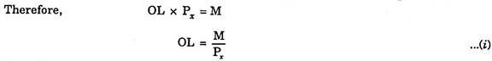
Now, the quantity of good Y purchased if whole of the given income M is spent on it is OB.
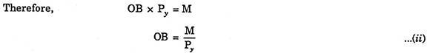
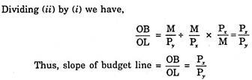

Consumer‘s Equilibrium
The state at which a consumer derives maximum utility from the consumption of one or more goods and services given his/her level of income is called consumer’s equilibrium. At that level of balance between total utility and income, the marginal utility of a product is equal to its one unit price.

What are the Assumptions for Attaining Consumer’s Equilibrium?
For Consumers Equilibrium in Case of a Single Commodity, We Assume –
- Consumer is rational and thus attempts to maximise his/her total utility
- Fixed level of income of a consumer
- Fixed price of a commodity in question

In the Case of Consumer’s Equilibrium for Two or More Commodities, We Assume that –
- Consumer is rational and strives to maximise his/her total utility
- Fixed level of income of a consumer
- Fixed prices of commodities
- Commodities are homogeneous or perfect substitutes

Conditions of Consumer’s Equilibrium for One Commodity
- Parity between marginal utility and per-unit price
A consumer attains equilibrium at such level where marginal utility derived from the consumption of a commodity is equal to its one unit price.

Marginal utility is the change in the total utility of a commodity.
It is expressed as MU = TU_{n+1} - TU_{n}
Here,
- MU stands for Marginal Utility
- TU stands for Total utility
- n stands for the number of units consumed

Importance of Consumer Equilibrium
- It allows a consumer to maximise his/her utility from the consumption of one or more commodities.
- It helps arrange the combination of two or more products based on consumer taste and preference for maximum utility.

Law of Supply

Law of supply depicts the producer behavior at the time of changes in the prices of goods and services. When the price of a good rises, the supplier increases the supply in order to earn a profit because of higher prices.

According to the law of supply, the quantity supplied increases with a rise in the price of a product and vice versa while other factors are constant. The other factors may include customer preferences, size of the market, size of population, etc

Determinants of Supply

Thus, it can be said that supply is the function of price and cost of production. These factors that influence the supply are called the determinants of supply
9 Determinants of supply are:
- Price of a product
- Cost of production
- Natural conditions
- Transportation conditions
- Taxation policies
- Production techniques
- Factor prices and their availability
- Price of related goods
- Industry structure

Assumptions of Law of Supply
Like the law of demand, the law of supply also follows the assumption of ceteris paribus, which means that ‘other things remain unchanged or constant’.
As mentioned earlier, the supply of a commodity is dependent on many factors other than price, such as consumers’ income and tastes, price of substitutes, natural factors, etc.
All the factors other than the price are assumed to be constant. The law of supply works on certain assumptions which are given as follows:

Assumptions of Law of Supply are:
- The income of buyers and sellers remains unchanged.
- The commodity is measurable and available in small units.
- The tastes and preferences of buyers remain unchanged.
- The cost of all factors of production does not change over a period of time.
- The time period under consideration is short.
- The technology used remains constant.
- The producer is rational.
- Natural factors remain stable.
- Expectations of producers and the government policy do not change over time.

Supply Curve
Supply Curve definition: In economics, supply curve is a graphical representation of supply schedule is called supply curve.
In a graph, the price of a product is represented on Y-axis and quantity supplied is represented on X-axis.

Types of Supply Curve
In, economics, Supply curve can be of two types, individual supply curve and market supply curve. These two types of supply curves are explained as follows:
Types of Supply Curve are:
- Individual supply curve
- Market Supply curve

Introduction
Numerical based chapter explaining Supply, determinants of individual supply and market supply, law of supply, movement along the supply, shift in supply, reasons and exceptions to the law of supply, price elasticity of supply and ways to measure it. It also takes into account the factors affecting the price elasticity of supply and concept of time horizon.
1. Stock refers to total quantity of a particular commodity that is available with the firm at a particular point of time.
2. (a) Supply refers to the quantity of a commodity that a firm is willing and able
to offer for sale, at each possible price during a given period of time.
(b) In other words, supply is that part of stock which is actually brought into the market for sale. Stock can never be less than supply.

(c) For example, a seller has a stock of 50 tonnes of sugar in the go down. If the seller is willing to sell 30 tonnes at a price of Rs. 37 per kg, then supply of 30 tonnes is a part of total stock of 50 tonnes.

3. Market supply refers to the quantity of a commodity that all firms are willing and able to offer for sale at each possible price during a given period of time.

4. Factors affecting personal (individual) supply:


- Price of the commodity:
(i) Positive relationship exists between price of the commodity and supply of that commodity.
(ii) It means, with the rise in price of the commodity, the supply of that commodity also rises and vice-versa.
- Price of the factors of production:
(i) This also influences the supply since price of factors (rent, wages, interest, profit) constitutes the cost of production of a commodity.
(ii) An increase in the price of a factor of production may lead to fall in production of a commodity shifting the supply curve to the left

(iii) As against it, a producer may supply more of a commodity at a given price if the prices of factors fall shifting the supply curve to the right.
- State of technology:
(i) When there is technological progress in the firm, then cost of production will decrease, which leads to increase in the profit margin of the firm and thereby shifts the supply curve rightward.
(ii) Supply of those goods which are being produced with old and inferior technology causing increase in cost of production will decrease the total output and shift the supply curve to the left.
- Unit tax:
(t) A unit tax is a tax that the government imposes per unit sale of output.
(ii) For example, suppose that the unit tax imposed by the government is ? 3. Then, if the firm produces and sells 20 units of the goods, the total tax that the firm must pay to the government is 20 * 3 = 60
- Price of other goods:
(i) Suppose a firm produces more than one product with its given resources.
(ii) An increase in the price of other goods induces the firm to produce more of other goods to earn more profit and less of goods whose prices remained unchanged.
- Objective of the firm:
(i) Sometimes a firm may be induced to increase supply of a commodity not because it is more profitable, but because its supply is a source of status and prestige in the market.
(ii) Similarly, a firm may increase production just to achieve the goal of maximum sale or maximum employment.

5.Factors affecting Market supply:
(a) Price of the commodity
(b) Price of the factors of production
(c) State of technology
(d) Unit tax
(e) Price of other goods
(f) Objective of the firm
(g) Number of firms in the market:
(i) When the number of firms in the industry increases, market supply also increases due to large number of producers producing that commodity.
(ii) However, market supply will decrease, if some of the firms start leaving the industry due to losses.
(h) Future Expectation regarding price:
(i) If sellers expect a rise in price in near future, current market supply will decrease in order to raise the supply in future at higher prices.
6. Supply function shows the relationship between quantity supplied for a particular commodity and the factor influencing it.
7. Individual supply function refers to the functional relationship between supply and factors affecting the supply of a commodity.

It is expressed as, Sx = f (P_{x} , P₀ , P_{f}, S_{t} , T, O) Where, S_{x} = Supply of the given commodity x.
P_{x}= Price of the given commodity x.
P₀ = Price of other goods.
P_{f} = Prices of factors of production.
S_{t}= State of technology.
T = Taxation policy.
O = Objective of the firm8. (a) Market supply function refers to the functional relationship between market supply and factors affecting the market supply of a commodity.
(b) As we know, market supply is affected by all the factors affecting the individual supply.
(c) In addition, it is also affected by some other factors like number of firms, future expectations regarding price and means of transportation and communication. Market supply function is expressed as, S_{x} = f(P_{x}, P₀, P_{f}, S_{t}, T, O, N, F, M)
Where, S_{x} = Market supply of given commodity x.
P_{x}= Price of the given commodity x.
P₀ = Price of other goods.
P_{f} = Prices of factors of production.
S_{t}= State of technology.
T = Taxation policy.
O = Objective of the firm.
N = Number of firms.
F = Future expectation regarding price of given commodity x.
M = Means of transportation and communication.

9. Supply schedule is a table showing various quantities of a commodity offered for sale corresponding to different possible prices of that commodity.
Supply schedule is of two types:
(a) Individual supply schedule
(b) Market supply schedule.
10. Individual supply schedule refers to the supply schedule of an individual firm in the market.
Table shows a hypothetical supply schedule for commodity ‘x

11.Market supply schedule refers to supply schedule of all the firms in the market producing a particular commodity.

12. Supply curve refers to a graphical representation of supply schedule. It shows direct relationship between price and quantity supplied, keeping other factor constant. Supply curve is of two types

(a) Individual Supply Curve (b) Market Supply Curve
13. (a) Individual supply curve refers to a graphical representation of individual supply schedule.
(b) With the help of information given in supply schedule (see table), the supply curve for an individual firm can be drawn as shown in figure

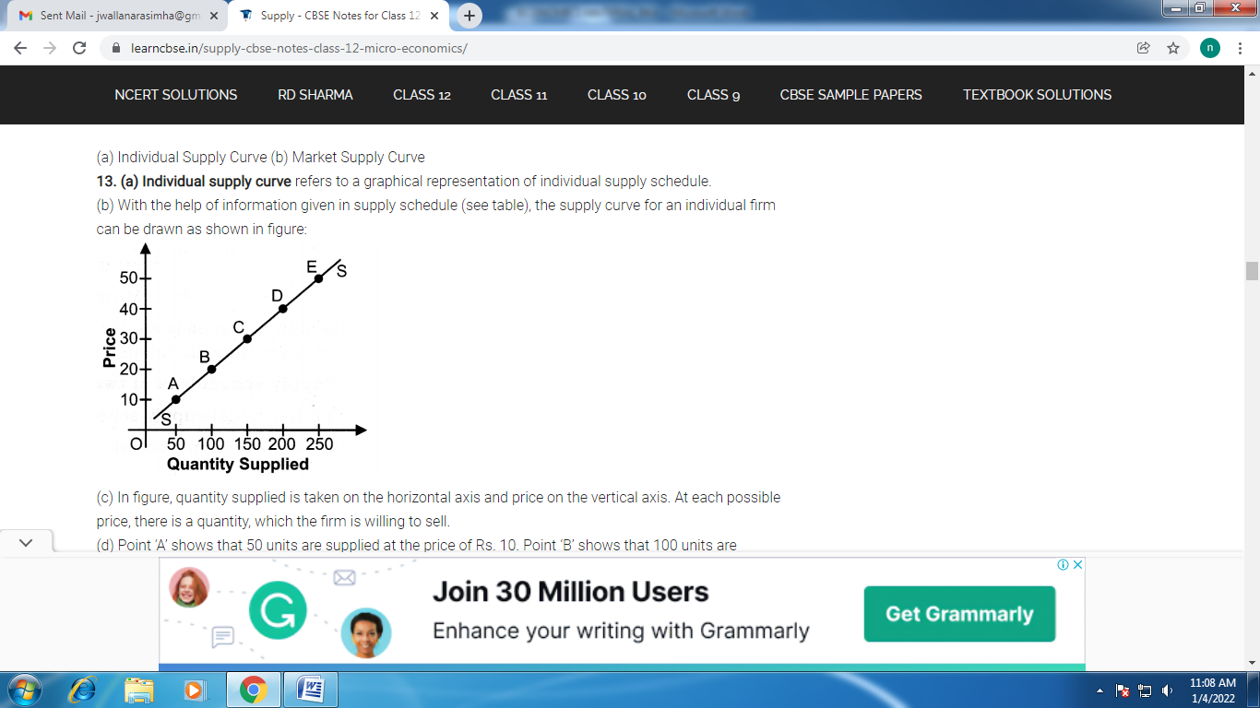

(c) In figure, quantity supplied is taken on the horizontal axis and price on the vertical axis. At each possible price, there is a quantity, which the firm is willing to sell.
(d) Point ‘A’ shows that 50 units are supplied at the price of Rs. 10. Point ‘B’ shows that 100 units are supplied at Rs. 20.
(e) By joining all the points (A to E), we get a curve that slopes upward. The supply curve SS slopes upward due to positive relationship between price and quantity supplied.
14. (a) Market supply curve refers to a graphical representation of market supply
schedule. It is obtained by horizontal summation of individual supply curves.
(b) Let us graphically convert the market supply schedule (table) into a market supply curve (see figure)

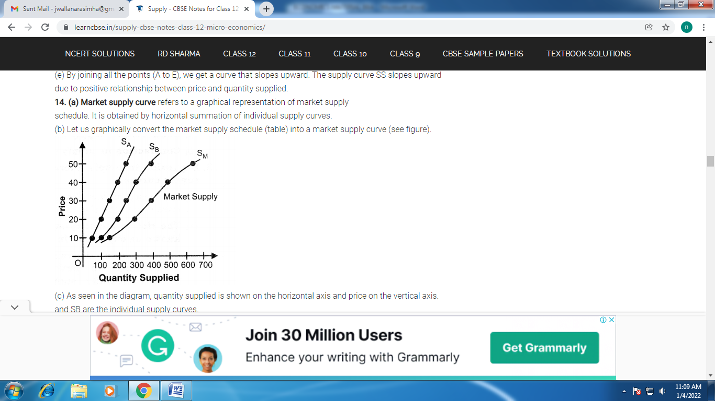

(c) As seen in the diagram, quantity supplied is shown on the horizontal axis and price on the vertical axis. and SB are the individual supply curves.
Market supply curve (SJ) is obtained by horizontal summation of the individual supply curves.
(d) At the price of Rs. 10 per unit both the firms will supply a total number of 150 units. When price rises to Rs. 20 per unit, market supply rises to 300 units.
(e) Market supply curve is also positively sloped
due to positive relationship between price and quantity supplied. Quantity Supplied
15. Market supply curve is flatter than all individual supply curves. It happens because with a rise in price, the proportionate rise in market supply is more than the proportionate rise in individual supplies.
16. (a) Other things being constant (Ceteris Paribus), based on price of the commodity; then it is known as Law of Supply.
It means, quantity supplied of the commodity rises due to rise in price of the commodity and vice-versa.
(b) Ceteris Paribus means:
(i) Price of other commodity remains constant.
(ii) Technology of production should not change.
(iii) Cost of production remains constant.
(iv) Taxation policy of the government should not change.
(v) Objective of the firm remains constant.
(c) The law of supply makes a qualitative statement only and not quantitative. It indicates the direction of change in the amount supplied and it does not indicate the magnitude of change.
(d) Law of supply is one sided. It explains only the effect of change in price on the quantity supplied. It states nothing about the effect of change in quantity supplied on the price of the commodity.

(e) The schedule and diagram are as follows:

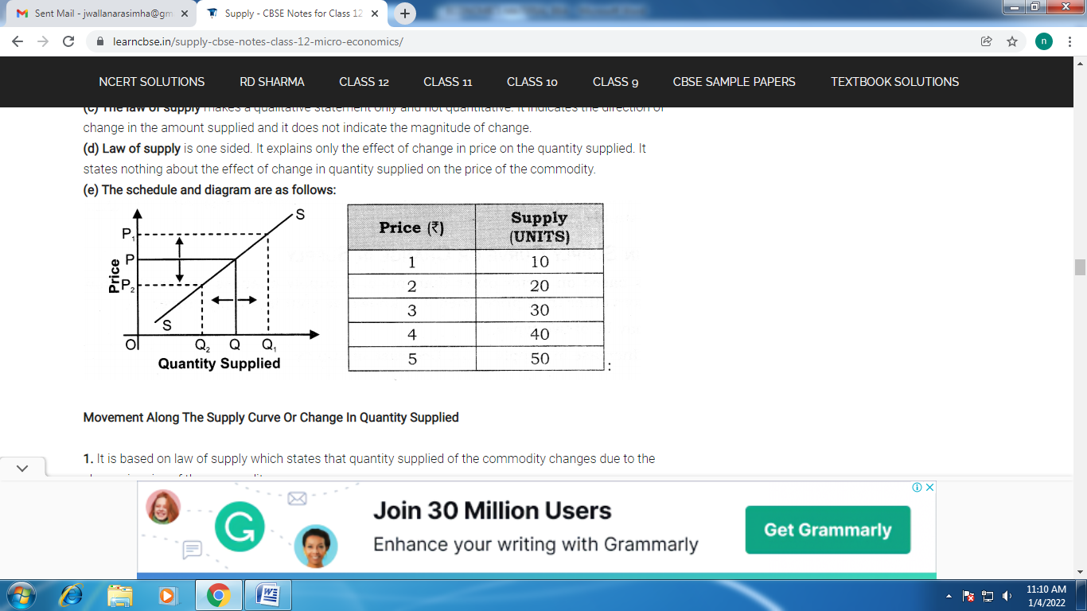
Movement Along The Supply Curve Or Change In Quantity Supplied
1. It is based on law of supply which states that quantity supplied of the commodity changes due to the change in price of the commodity.
2. The change in quantity supply due to the change in the price of the commodity is known as Movement along the supply curve. It may be of two types; namely,
(a) Expansion in supply (increase in quantity supplied)
(b) Contraction in supply (decrease in quantity supplied)
3. Expansion in supply (increase in quantity supplied or upward movement along supply curve):
(a) It is based on law of supply which states that quantity supplied of a commodity rises due to the rise in price of the commodity.
(b) The rise in quantity supplied due to the rise in price of the commodity is known as expansion in supply

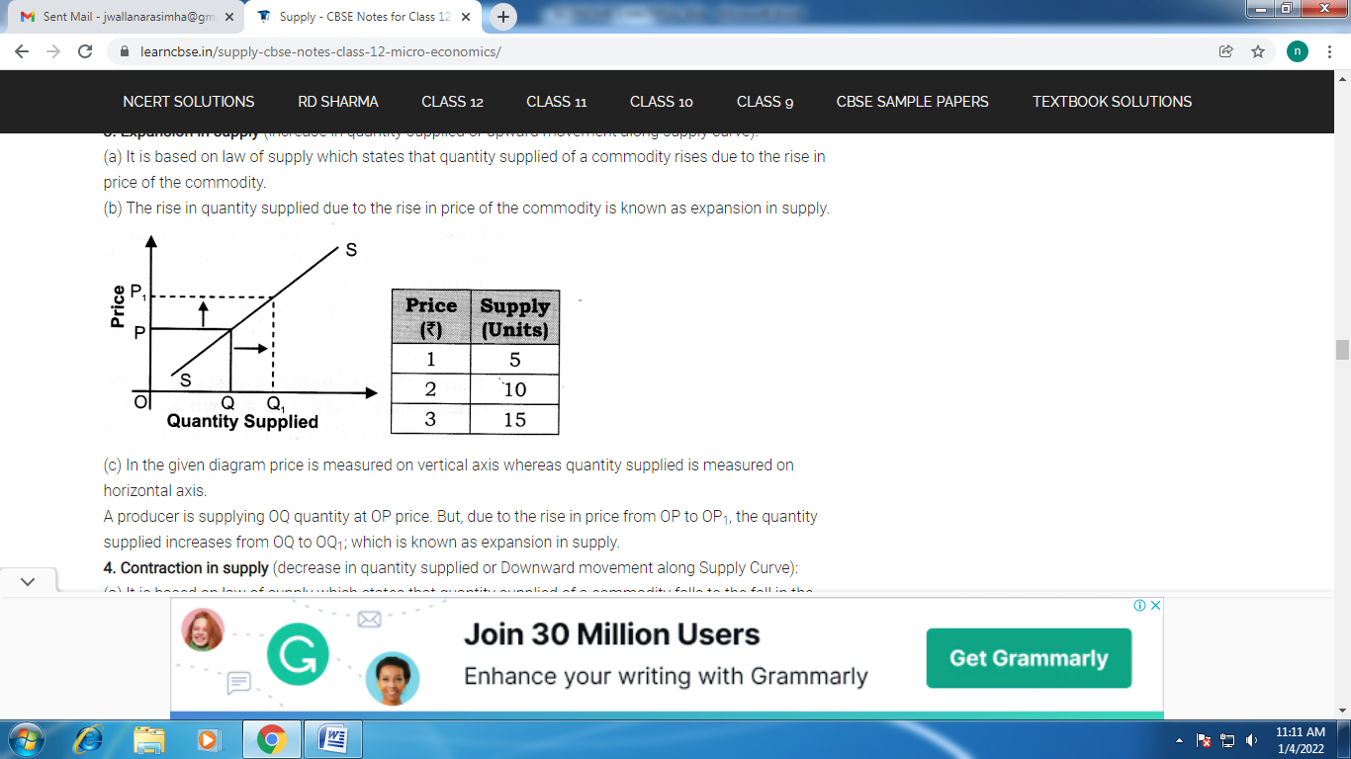

(c) In the given diagram price is measured on vertical axis whereas quantity supplied is measured on horizontal axis.
A producer is supplying OQ quantity at OP price. But, due to the rise in price from OP to OP₁, the quantity supplied increases from OQ to OQ₁; which is known as expansion in supply.
4. Contraction in supply (decrease in quantity supplied or Downward movement along Supply Curve):
(a) It is based on law of supply which states that quantity supplied of a commodity falls to the fall in the price of the commodity.
(b) The fall in the quantity supplied due to the fall in price of the commodity is known as contraction in supply.

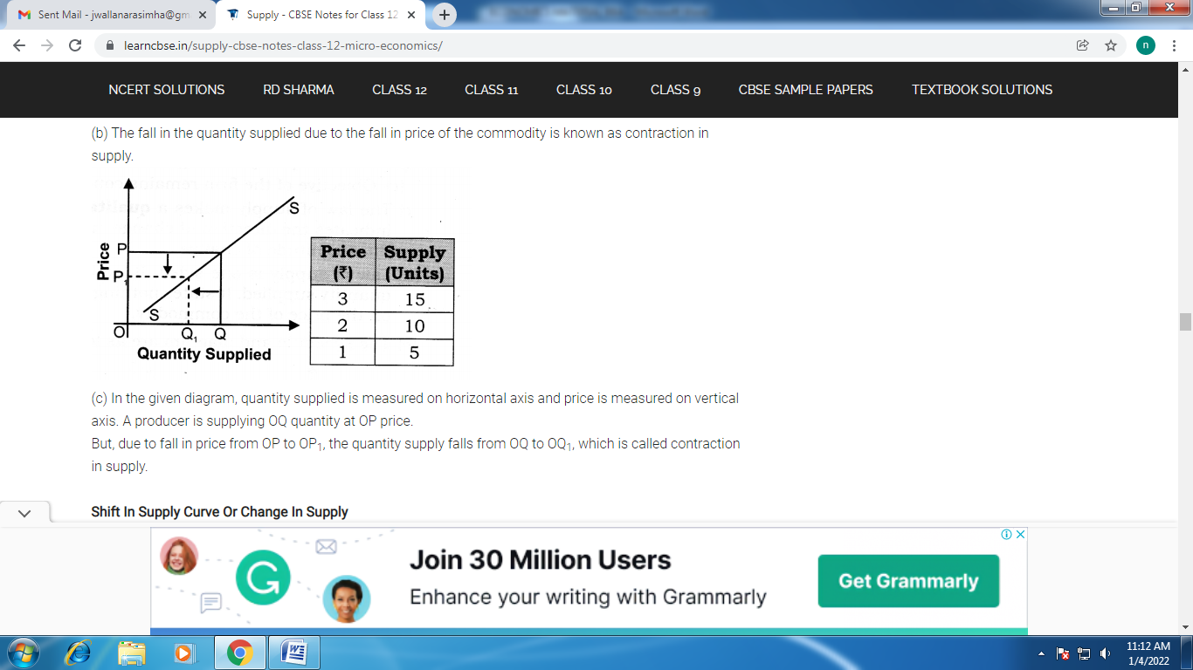
Shift In Supply Curve Or Change In Supply
1. It is based on factor other than price. If supply changes due to the change in the factors other than price, then it is known as shift in supply curve.
2. It may be of two types:
(a) Increase in supply (b) Decrease in supply
(a) Increase in supply:
(i) An increase in supply means that producers now supply more at a given level of price of a commodity.
(ii) It’s conditions are:
• Fall in the prices of remuneration of factors of production.
• Fall in the prices of other commodities.
• Improvement in technology.
• Taxation policy of government falls.
• Change in objective of producer (inducing them to increase supply at the same price.)
(iii) In the given diagram price is measured on vertical axis whereas, quantity supplied is measured on horizontal axis. A producer is supplying OQ quantity at OP price.
But, due to the changes in the factors other than price, the supply curve shifts rightward from SS to S₁S₁.

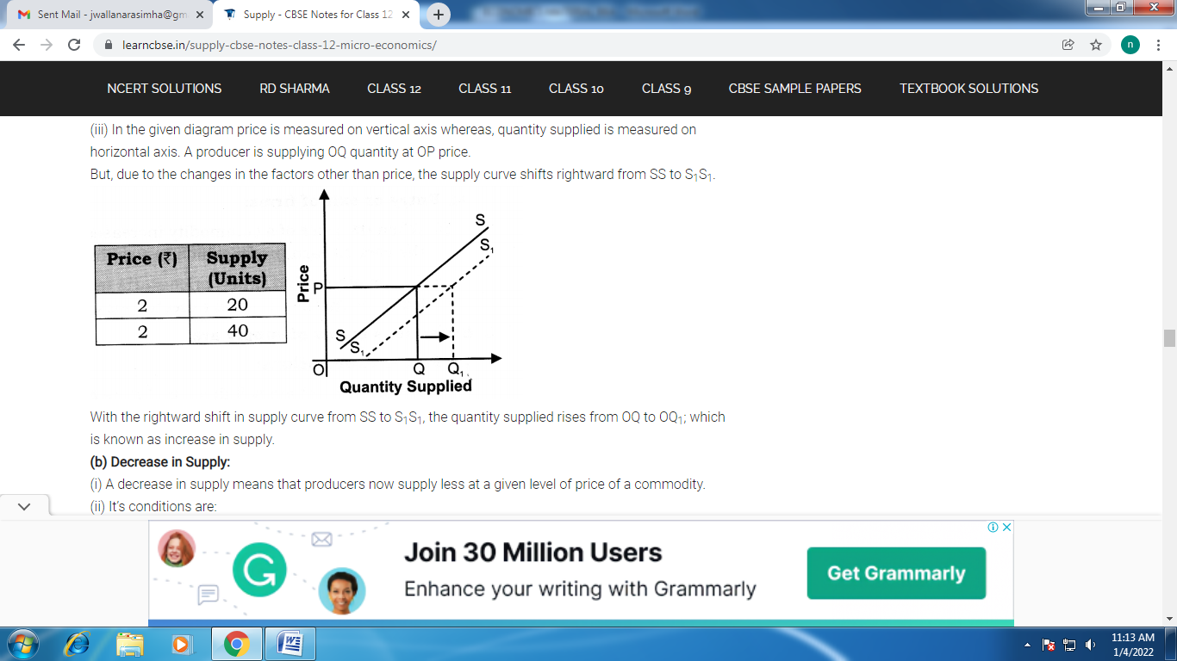

With the rightward shift in supply curve from SS to S₁S₁, the quantity supplied rises from OQ to OQ₁; which is known as increase in supply.
(b) Decrease in Supply:
(i) A decrease in supply means that producers now supply less at a given level of price of a commodity.
(ii) It’s conditions are:
• Rise in the prices of remuneration of factors of production.
• Rise in the prices pf other goods.
• When the technology becomes outdated.
• Taxation policy of government rises.
• Change in objective of producer (inducing them to decrease supply at the same price).
(iii) In the given diagram, quantity supplied is measured on horizontal axis whereas price is measured on vertical axis. A producer is supplying OQ quantity at OP price

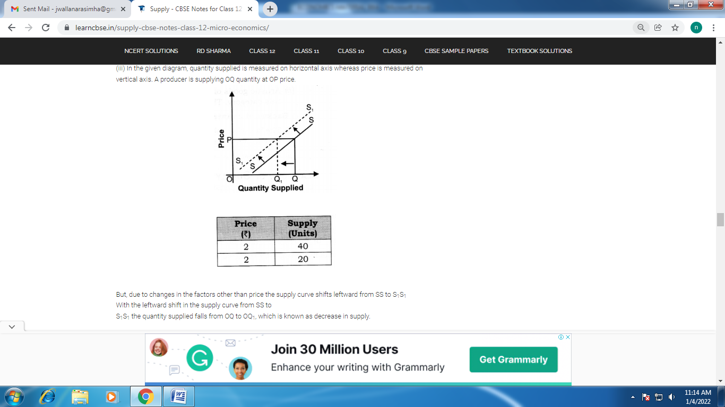
Causes And Exceptions To The Law Of Supply
1. There is a positive relationship between price of the commodity and quantity supplied for that commodity which causes supply curve to slope upward from left to right.
2. It is because of the following reasons:
(a) Change in stock:
(i) With the increase in the price of the commodity sellers are ready to sell more from their old stock of goods.
(ii) On the other hand, when price of a commodity decreases, sellers would like to increase their stock to avoid losses.
(b) Profit and loss: With the rise in price producers generally increase their production in view of higher profit possibilities and vice-versa.
(c) Entry or exit of firms:
(i) When the price of a commodity increases, new firms enter into the industry with the view to earn profits which in turn increases the supply.
(ii) On the other hand, when price starts falling, marginal firms (or inefficient firms) leave the market to avoid expected losses which thereby decreases the supply.
3. Exceptions to law of supply are:
(a) Future expectations:
(i) The law will not apply if there are future expectations for further change in prices.
(ii) For example, if sellers expect further fall in prices in future, they would be ready to sell more even at low prices.
(b) Agricultural goods: The supply of agricultural goods depends more on natural factors such as drought, floods, natural calamities etc. and less on their prices.
(c) Perishable goods: The supply of perishable goods, like milk, vegetables, fish, eggs, etc. is also not affected by their prices. Sellers cannot hold these goods for long.
(d) Rare articles:
(i) In case of some precious and rare goods also, the law of supply does not apply.
(ii) Artistic goods of high quality and poems written by top class poets come under this categoiy. Their supply cannot be increased even when their prices rise.
(e) Backward countries:
(i) The law of supply loses its applicability in backward countries where production and supply cannot be increased merely because of rise in prices.
(ii) Here resources which are urgently required for production are lacking.

Elasticity Of Supply And Price Elasticity Of Supply(PES/ES)
1. The degree of responsiveness of quantity supplied due to the changes in determinants of supply (price of other commodity, price of factors of production, technology, etc.) is known as elasticity of supply.

2. (a) The degree of responsiveness of quantity supplied due to the changes in price of the commodity is known as price elasticity of supply.
(b) It is quantitative statement, i.e., it tells us the magnitude of the change in quantity supplied as a result of change in price.
3. Percentage method/flux method for calculating price elasticity of supply:
According to this method, elasticity is measured as the ratio of percentage change in the quantity supplied to percentage change in the price.
(a) Percentage change in quantity supplied = Injtw Quantity Supplie(J |Q)
(b) Change in Quantity (AQ) = New Quantity (QJ – Initial Quantity (Q)
(c)Price elasticity of supply (ES) = Now,
(d) Change in Price (AP) = New Price (P,) – Initial Price (P)
Proportionate Method: The percentage method can also be converted into the proportionate method: Putting the values of (a), (b), (c) and (d) in the formula of percentage method, we get,

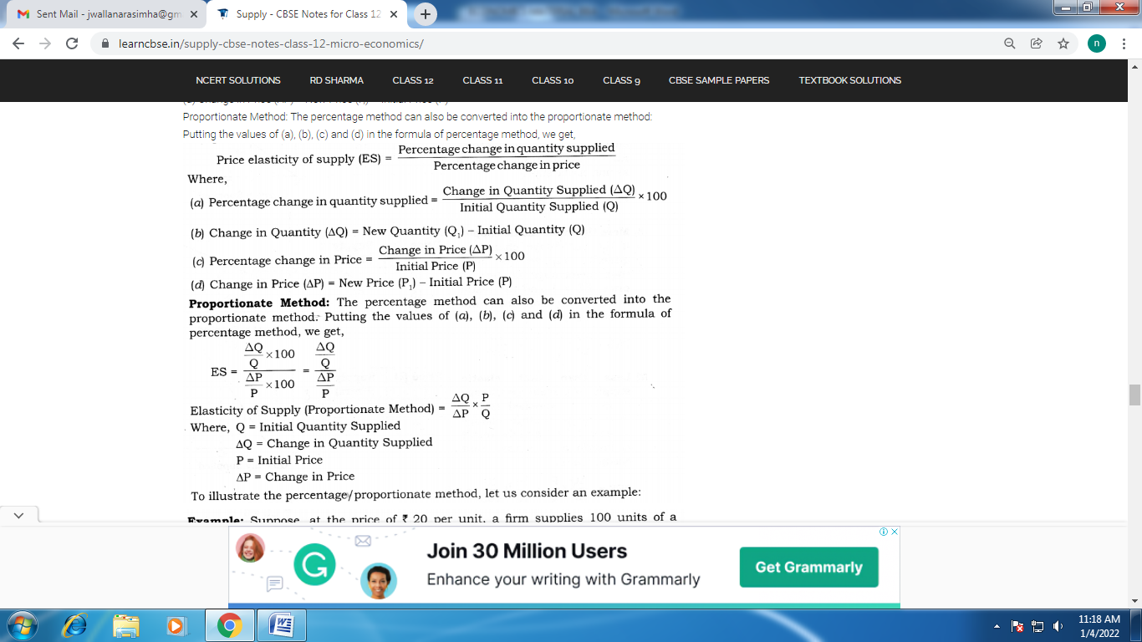

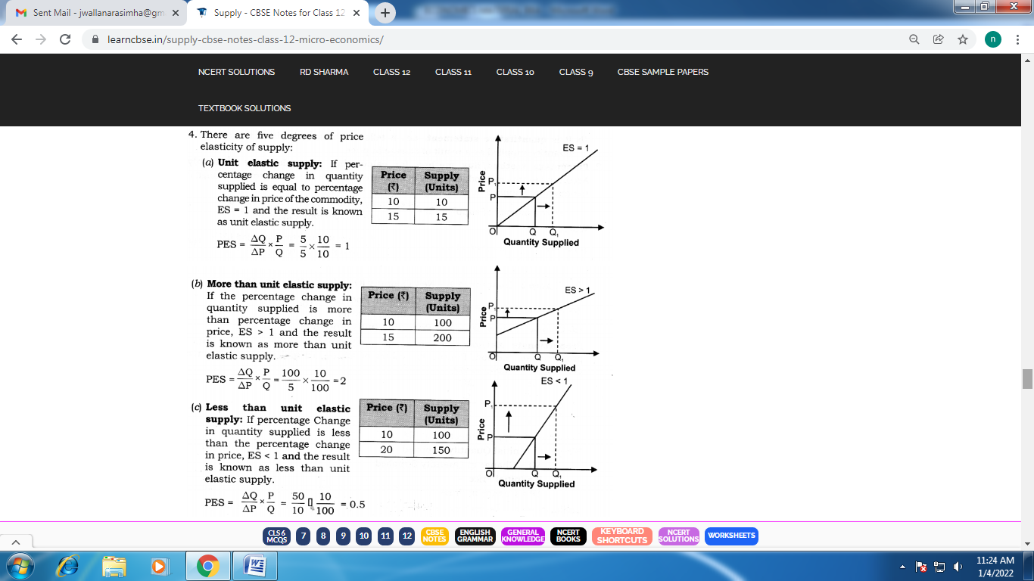

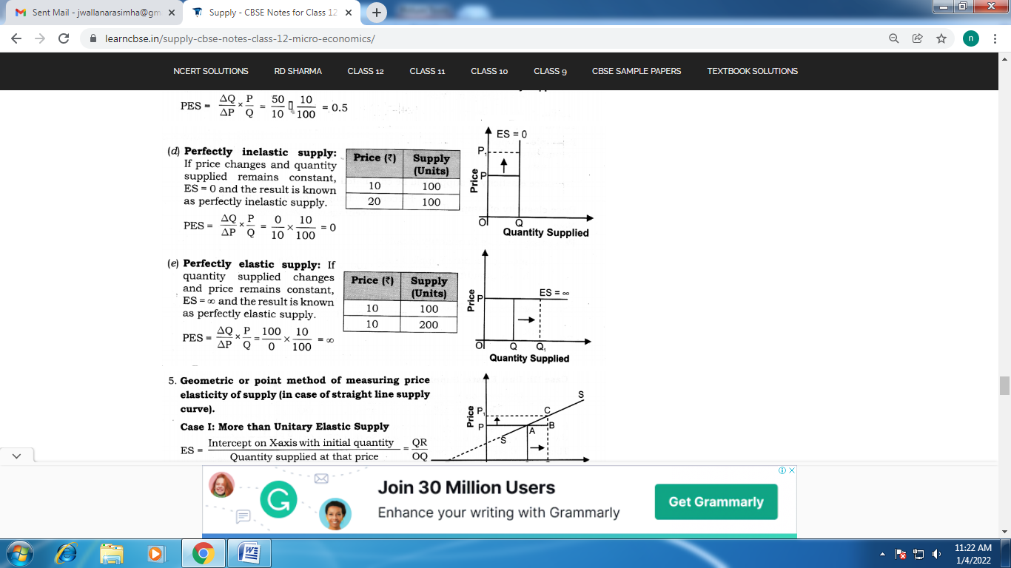

6.Factors Affecting Price Elasticity of Supply:
(a) Nature of the commodity: Elasticity of supply to some extent depends upon the nature of the commodity.
(i) For example, perishable goods have inelastic supply (because their supply cannot be increased or decreased) while the supply of durable goods is elastic.
(ii) Likewise, the supply of agricultural goods is inelastic while it is elastic in case of industrial goods.
(b) Cost of production
(i) If cost of production rises rapidly with the increase in output, there is less incentive to raise the supply with the increase in price. In such cases, supply will be inelastic.
(ii) However, if cost of production increases slowly with the rise in output, supply will increase with the rise in prices. In this case, supply will be more elastic.
(c) Time period
(i) In the market period, supply of a commodity is perfectly inelastic as supply cannot be changed immediately with the change in price.
(ii) In the short period, supply is relatively less elastic as firm can change the supply by changing the variable factors.
(iii) In the long period, supply is more elastic as all the factors can be changed and supply can be easily adjusted as per changes in price.
(d) Technique of production
(i) If simple techniques of production are employed in the production of a commodity, its supply will be elastic.
(ii) On the other hand, it becomes very difficult to change supply (in response to change in price) under complex techniques of production.
(e) Availability of resources and facilities
(i) The production of a commodity requires adequate resources and other facilities like irrigation, power, transportation, banking, etc. The producers feel handicapped in their absence or shortage. Hence, supply becomes inelastic.
(ii) On the other hand, if these resources and facilities are easily and adequately available, producers can easily respond to any change in price.
7. Time Horizons And Supply Curve
Time period which is available to a firm to adjust its supply also plays an important role in the shapes of supply curves

UNIT –IV

Production;
Production refers to the process of using various inputs to obtain the required output. The output is called production. It should be qualitative and quantitative. This is what production stands for in simple words, however, production is a vast topic. So besides knowing its meaning, we need to know its factors, its types, and its significance as well.

Types of Production:

1. Based on economics
We have several types of productions since economists have categorized them in multiple ways. The first classification is of four types and these are as follows.
- Unit or Job Production: It is a single unit of production to a single customer. The name unit indicates the same theory. Restaurants, tailoring shops, bakeries, etc. can come under this category. Its features depend on customer service and support. It depends more on the human resources like skill, communication, etc. than the machinery.
- Batch Production: It is another essential classification that concentrates on producing a group of products in the same period. Mostly durables and appliances can come under this type of production. The manufacturer will come to know the number of products required before the production starts. It depends on the season. It has a high risk of production if it needs to stop in the middle. FMCG, electronic appliances are examples of this.
- Mass or Flow Production: It has two names. It applies to large scale industries, as they produce goods in a bulk amount, after completing a lot of production, they start again. It requires huge capital. Car manufacturers belong to this production. It produces in high volumes and considers the standardization.
- Continuous or Process Production: It has a few similarities with mass production but is a completely different kind of production. Here, the process plays a vital role because the manufacturing process goes on continuously. Brewing is an example of continuous production. It requires machinery more than manual power.
2.BASED ON PROCESS:
we have another classification of production based on a process. They are as follows.
- Primary Production: It is the first phase of the production process. The collection and extraction of raw materials take place in this stage. It plays a vital role in hardware and large scale industries. In this phase, the collection of funds and investment are essential.
- Secondary Production: It is the mid-phase of production. It involves both machinery and manual work in parallel. It focuses on the utilization of raw materials effectively to get more productivity. Here we need working capital.
- Tertiary Production: It is the last and significant phase as all the packaging, and distribution of goods happens here. It is the phase where we can earn returns for our qualitative products. It involves certain risks too.
Factors of production refer to the different elements that are used in producing goods and services.
The four main factors of production are:
- Land – this is raw materials available from mining, fishing, agriculture
- Capital – This is a manufactured item used to aid production, for example, machines, factories and computers
- Labour – Human workers who are involved in producing the good.
- Entrepreneur – the individual or business who take the initiative to set up a business and employ different factors of production (labour, capital and entrepreneur)

Other potential factors of production
- Knowledge – human capital – the skills and ability of workers. For example, a doctor who spent 15 years studying medicine is more productive than non-skilled workers.
- State of technology – some schools of economics consider the state of technological development to be a factor of production. It will influence the effectiveness of capital investment.
- Social capital – the coherence of society. Is there trust and working legal systems which enable entrepreneurs to have greater faith in setting up a business
- Cultural heritage – if there is a strong tradition of investment and business, it is easier to replicate past business models.

Land – raw materials
- Oil
- Coal
- Fish
- Agricultural produce – fruit, vegetables, meat
- Commercial real estate – land to build factories

Labour (human resources)
- Workers – full time, part-time, temporary, permanent
- Management

Capital (man-made resources)
- Machines
- Tractors, spades
- Computers, Phone
- Office block
- Factory, Assembly line
- Public infrastructure – communication and roads needed to transport goods across the country.

Entrepreneurs (individuals who bring factors of production together
- Self-employed
- People who start up businesses – Anita Roddick, Bill Gates, Richard Branson
- Finance – Entrepreneurs needs access to money – either savings or loans from banks to get started

Production Function:
Production function is the equation that expresses the relationship between the quantities of productive factors (such as labour and capital) used and the amount of product obtained. It states the amount of product that can be obtained from every combination of factors, assuming that the most efficient available methods of production are used.

Production is the result of four factors of production i.e., land, labor, capital and organization support. This is evident from the fact that no single commodity can be produced without the help of one of these four factors of production.

Therefore, the manufacturer combines all four factors of production to technical ratios. Profit maximization is the only aim of the producer. For this, he decides to maximize production at the lowest cost through the best combination of factors of production

Relationship between Input and Output:
In simple terms, the production function refers to the functional relationship between the quantity of a good produced (production) and the factors of production (input).
Thus, the production function shows how much production we can expect if we have too much labor and so much capital as well as labor. In other words, we can say that the production function is an indicator of the physical relationship between the two inputs and outputs of a firm

Definition of production function by different professors

- Prof. Koutsoyiannis: – Defined as, “The production function is purely a technical relation which connects factor inputs and output.”

- Prof. Watson: – Defined production function as “The relation between a firm’s physical production (output) and the material factors of production (inputs).”

- Prof. L.R. Klein: – “The production function is a technical or engineering relation between input and output. As long as the natural laws of technology remain unchanged, the production function remains unchanged.”\

Features of Production Function
- Substitutability: – Thus the quantity of any output can vary with changes in the quantity of even one input while keeping other factors constant.
- Complementary: – Therefore, a producer can produce the output by mixing the factor inputs together. If the quantity of any input is zero, the output cannot be produced.
- Specificity: – For example, raw materials, specialized labor, machines, and equipment can be used for the production of the specific product. However, all these factors of production are not completely specialised as they can also be used in the production of other products.
- Production time: – Production of any type of product requires time. Production can only be possible in the long run. In the production function, the variation in total output is due to the variation in input quantity. The quantity of a single input may be possible in a short period of time.

Types of production functions: two types of production operations

1. Short run

2. Long runs: –
- Short Run Production Function: –
  - In short time period, the factors of production are fixed and variable.
  - In short run, it is not possible to change factors of production because of very less time.
  - A manufacturer cannot change the amount of capital such as machines, tools, equipment, factory houses, etc.
  - The manufacturer may change variable factors of production such as units of labor.
  - Factors of production that are given in quantity in the short term are known fixed factors of production.
  - Factors of production whose quantity can be changed are called variable factors of production.
  - Short-run refers to a period of time that is too short to allow a manufacturer to change its plant capacity, yet it is sufficient to change the level at which the fixed plant is used.

The short-term production function is written as: – Q = f (L) where, ‘Q’= Quantity of output and ‘L’= Labour
  - For example, an agricultural firm has 10 units of labor and 6 acres of land. Here, land is the constant factor and labor is the variable factor. The firm initially uses only one unit of labor (variable factor) on its land (constant factor). Hence the land-labor ratio is 6: 1. If the firm uses 2 units of labor, the land-labor ratio becomes 6: 2 or 3: 1.

- Long Run Production Function: –
  - In long-term production, all functions, factors of production are variable.
  - In a long-run output, all inputs are variable in a single output.
  - When long term is used to explain, it is called the law of returns on the scale.
  - In long run we measure that by how much proportion the output changes if we change the proportion of input.
  - From the point of view of existing firms, the long term refers to the period that is sufficient to allow these firms to change the quantities of all resources which are employed in the production, including plant capacity.
  - The producer can convert all inputs and establish the necessary plant capacity to maximize profit.

Long run production can be written as: – Q= f(L,C) Where, ‘Q’= Quantity of output, ‘L’= Labour and ‘C’= Capital
  - All production resources or inputs are variable over the long term.
  - For example, the builder can build a new building or expand an existing building, buy more new machines and equipment, open more branches of a production unit, buy more land to expand the firm’s size, can hire more and skilled workers, change production and managerial technology, etc

Fixed and Variable Factors of Production:
- A fixed factor of production is one whose quantity cannot readily be changed. Examples include major pieces of equipment, suitable factory space, and key managerial personnel.
- A variable factor of production is one whose usage rate can be changed easily. Examples include electrical power consumption, transportation services, and most raw material inputs.

Law of variable proportion:
- The law of variable proportions states that as the quantity of one factor is increased, keeping the other factors fixed, the marginal product of that factor will eventually decline. This means that up to the use of a certain amount of variable factor, marginal product of the factor may increase and after a certain stage it starts diminishing. When the variable factor becomes relatively abundant, the marginal product may become negative.
The law of variable proportions holds good under the following conditions:
- Constant State of Technology: First, the state of technology is assumed to be given and unchanged. If there is improvement in the technology, then the marginal product may rise instead of diminishing.
- Fixed Amount of Other Factors: Secondly, there must be some inputs whose quantity is kept fixed. It is only in this way that we can alter the factor proportions and know its effects on output. The law does not apply if all factors are proportionately varied.
- Possibility of Varying the Factor proportions: Thirdly, the law is based upon the possibility of varying the proportions in which the various factors can be combined to produce a product. The law does not apply if the factors must be used in fixed proportions to yield a product.

Three Stages of the Law of Variable Proportions:
Stage 1. Stage of Increasing Returns: In this stage, total product increases at an increasing rate up to a point. This is because the efficiency of the fixed factors increases as additional units of the variable factors are added to it. In the figure, from the origin to the point F, slope of the total product curve TP is increasing i.e. the curve TP is concave upwards up to the point F, which means that the marginal product MP of labour rises. The point F where the total product stops increasing at an increasing rate and starts increasing at a diminishing rate is called the point of inflection. Corresponding vertically to this point of inflection marginal product of labour is maximum, after which it diminishes. This stage is called the stage of increasing returns because the average product of the variable factor increases throughout this stage. This stage ends at the point where the average product curve reaches its highest point.
Stage 2. Stage of Diminishing Returns: In this stage, total product continues to increase but at a diminishing rate until it reaches its maximum point H where the second stage ends. In this stage both the marginal product and average product of labour are diminishing but are positive. This is because the fixed factor becomes inadequate relative to the quantity of the variable factor. At the end of the second stage, i.e., at point M marginal product of labour is zero which corresponds to the maximum point H of the total product curve TP. This stage is important because the firm will seek to produce in this range.
Stage 3. Stage of Negative Returns: In stage 3, total product declines and therefore the TP curve slopes downward. As a result, marginal product of labour is negative and the MP curve falls below the X-axis. In this stage the variable factor (labour) is too much relative to the fixed factor.

Law of returns to scale:
The law of returns to scale explains the proportional change in output with respect to proportional change in inputs.
In other words, the law of returns to scale states when there are a proportionate change in the amounts of inputs, the behavior of output also changes.
The degree of change in output varies with change in the amount of inputs. For example, an output may change by a large proportion, same proportion, or small proportion with respect to change in input.
On the basis of these possibilities, law of returns can be classified into three categories:
    - Increasing returns to scale
    - Constant returns to scale
    - Diminishing returns to scale

1. Increasing Returns to Scale:
If the proportional change in the output of an organization is greater than the proportional change in inputs, the production is said to reflect increasing returns to scale. For example, to produce a particular product, if the quantity of inputs is doubled and the increase in output is more than double, it is said to be an increasing returns to scale. When there is an increase in the scale of production, the average cost per unit produced is lower. This is because at this stage an organization enjoys high economies of scale
There a number of factors responsible for increasing returns to scale.
Some of the factors are as follows:

i. Technical and managerial indivisibility:
Implies that there are certain inputs, such as machines and human resource, used for the production process are available in a fixed amount. These inputs cannot be divided to suit different level of production. For example, an organization cannot use the half of the turbine for small scale of production.

ii. Specialization:
Implies that high degree of specialization of man and machinery helps in increasing the scale of production. The use of specialized labor and machinery helps in increasing the productivity of labor and capital per unit. This results in increasing returns to scale.

iii. Concept of Dimensions:
Refers to the relation of increasing returns to scale to the concept of dimensions. According to the concept of dimensions, if the length and breadth of a room increases, then its area gets more than doubled.

2. Constant Returns to Scale:
The production is said to generate constant returns to scale when the proportionate change in input is equal to the proportionate change in output. For example, when inputs are doubled, so output should also be doubled, then it is a case of constant returns to scale.

3. Diminishing Returns to Scale:
Diminishing returns to scale refers to a situation when the proportionate change in output is less than the proportionate change in input. For example, when capital and labor is doubled but the output generated is less than doubled, the returns to scale would be termed as diminishing returns to scale.

Concept of Cost
The concept of cost is a key concept in Economics. It refers to the amount of payment made to acquire any goods and services. In a simpler way, the concept of cost is a financial valuation of resources, materials, undergone risks, time and utilities consumed to purchase goods and services

The concept of cost can be effortlessly comprehended by classifying the costs. The process of grouping costs is based on similarities or common characteristics. A well-defined classification of costs is certainly essential to mention the costs of cost centres. The different types of cost concept are:
- Outlay costs and Opportunity costs
- Accounting costs and Economic costs
- Direct/Traceable costs and Indirect/Untraceable costs
- Incremental costs and Sunk costs
- Private costs and Social costs
- Fixed costs and Variable costs

Based On The Nature of Expenses
1. Outlay Costs
The authentic payments undergone by an entrepreneur in employing input is known as outlay cost. It includes costs on payments of fuel, rent, electricity, etc.
2. Concept of Opportunity Cost
It is the value of the next best thing you give up whenever a decision is made by you.

Classification In Terms Of Traceability
- Direct Costs
A direct cost is a cost that is related to the production method of a good or service. It is the opposite of an indirect cost.
These costs are related to a certain product or a process. They are also known as traceable costs as it could be traced to a specific activity. It is the opposite of an indirect cost.
2. Indirect Costs
Indirect costs are the expenses that could not be traced back to a single cost object or cost source. They are also known as untraceable costs. However, they are extremely important as they affect the total profitability.

The Cost Function:
The cost function expresses a functional relationship between total cost and factors that determine it. Usually, the factors that determine the total cost of production (C) of a firm are the output (0, the level of technology (T), the prices of factors (P_{f}) and the fixed factors (F). Symbolically, the cost function becomes
C=f (Q, T, P_{f}, F)
The remaining factors are variable whose supply is assumed to be known and available at fixed market prices. Further, the technology which is used for the production of the good is assumed to be known and fixed. Lastly, it is assumed that the firm adjusts the employment of variable factors in such a manner that a given output Q of the good q is obtained at the minimum total cost, C.
Thus the total cost function is expressed as:
C=f (Q)
Which means that the total cost (C) is a function if) of output (Q), assuming all other factors as constant. The cost function is shown diagrammatically by a total cost (TC) curve. The TC curve is drawn by taking output on the horizontal axis and total cost on the vertical axis,

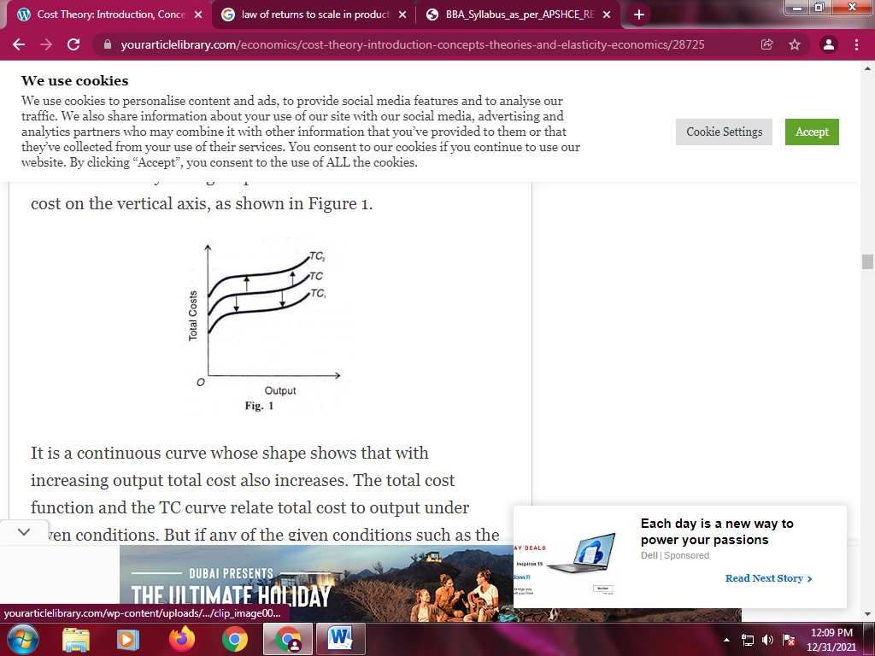

Cost-Output Relation
The Cost-output relation is discussed in the traditional and modem theories of costs under the short-run and long-run cost analysis which are explained as under.

The Traditional Theory of Costs:
The traditional theory of costs analyses the behaviour of cost curves in the short run and the long run and arrives at the conclusion that both the short run and the long run curves are U-shaped but the long-run cost curves are flatter than the short-run cost curves
(A) Firm’s Short-Run Cost Curves:
The short run is a period in which the firm cannot change its plant, equipment and the scale of organisation. To meet the increased demand, it can raise output by hiring more labour and raw materials or asking the existing labour force to work overtime.
Short-Run Total Costs:
The scale of organisation being fixed, the short-run total costs are divided into total fixed costs and total variable costs:
TC = TFC + TVC
Total Costs or TC:
Total costs are the total expenses incurred by a firm in producing a given quantity of a commodity. They include payments for rent, interest, wages, taxes and expenses on raw materials, electricity, water, advertising, etc.
Total Fixed Costs or TFC:
Are those costs of production that do not change with output. They are independent of the level of output. In fact, they have to be incurred even when the firm stops production temporarily. They include payments for renting land and buildings, interest or borrowed money, insurance charges, property tax, depreciation, maintenance expenditures, wages and salaries of the permanent staff, etc. They are also called overhead costs.
Total Variable Costs or TVC:
Are those costs of production that change directly with output. They a rise when output increases, and fall when output declines. They include expenses on raw materials, power, water, taxes, hiring of labour, advertising etc., They are also known as direct costs.
The relation between total costs, variable costs and fixed costs is presented in Table 1, where column (1) indicates different levels of output from 0 to 10 units. Column (2) indicates that total fixed costs remain at Rs. 300 at all levels of output. Column (3) shows total variable costs which are zero when output is nothing and they continue to increase with the rise in output.
In the beginning they rise quickly, and then they slow down as the firm enjoys economies of large scale production with further increases in output and later on due to diseconomies of production, the variable costs start rising rapidly. Column (4) relates to total costs which are the sum of columns (2), and (3) i.e., TC – TFC + TVC. Total costs vary with total variable costs when the firm starts production.

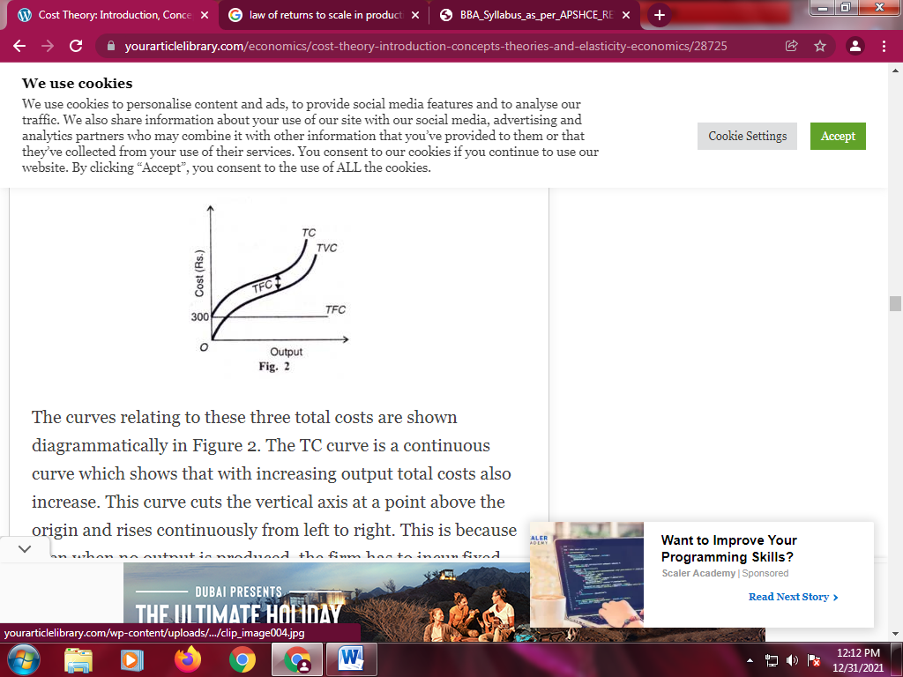
(B) Firm’s Long-Run Cost Curves:
In the long run, there are no fixed factors of production and hence no fixed costs. The firm can change its size or scale of plant and employ more or less inputs. Thus in the long run all factors are variable and hence all costs are variable.
The long run average total cost or LAC curve of the firm shows the minimum average cost of producing various levels of output from all-possible short-run average cost curves (SAC). Thus the LAC curve is derived from the SAC curves. The LAC curve can be viewed as a series of alternative short-run situations into any one of which the firm can move
Let there be three plants represented by their short-run average cost curves SAC₁ SAC₂ and SAC₃ in Figure 4. Each curve represents the scale of the firm. SAС₁depicts a lower scale while the movement from SAC₂ to SA С₁ shows the firm to be of a larger size. Given this scale of the firm, it will produce up to the least cost per unit of output. For producing ON output, the firm can use SAC₁or SAC₂ plant.

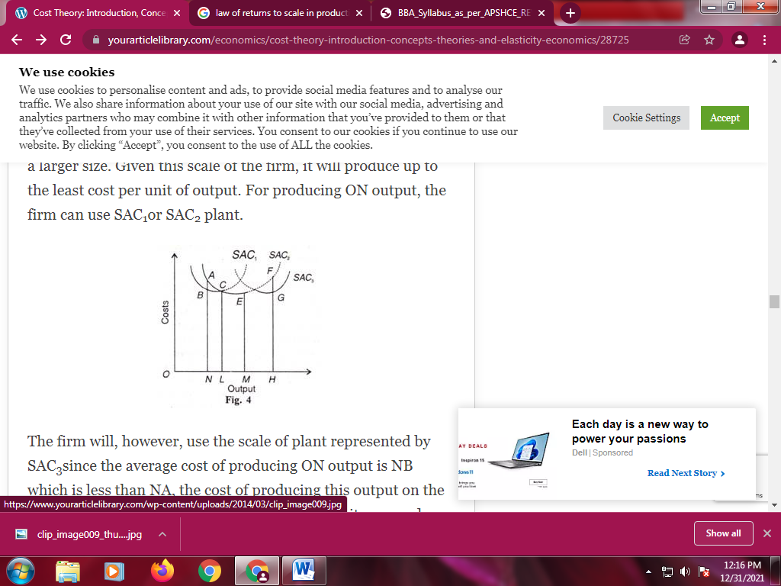
If the firm expands its scale by the three stages represented by SAC₁SAC₂and SAC₃ curves, the thick wave-like portions of these curves form the long-run average cost curve. The dotted portions of these SAC curves are of no consideration during the long run because the firm would change the scale of plant rather than operate on them.
But the long-run average cost curve LAC is usually shown as a smooth curve fitted to the SAC curves so that it is tangent to each of them at some point, as shown in Figure 5, where SAC_{1,}SAC_{2,} SAC₃, SAC₄ and SAC₅are the short-run cost curves. It is tangent to all the SAC curves but only to one at its minimum point.

LAC Curve Flatter than SAC Curve:
Though the long-run average cost (LAC) curve is U-shaped, yet it is flatter than the short-run average cost (SAC) curve. It means that the LAC curve first falls slowly and then rises gradually after a minimum point is reached.
  - Initially, the LAC gradually slopes downwards due to the availability of certain economies of scale like the economical use of indivisible factors, increased specialisation and the use of technologically more efficient machines or factors. The returns to scale increase because of the indivisibility of factors of production.
  - After the minimum point of the long-run average cost is reached, the LAC curve may flatten out over a certain range of output with the expansion of the scale of production. In such a situation, the economies and diseconomies balance each other and the LAC curve has a disc base.
  - With further expansion of scale, the diseconomies like the difficulties of coordination, management, labour and transport arise which more than counterbalance the economies so that the LAC curve begins to rise. This happens when the indivisible factors become inefficient and less productive due to the over expansion of the scale of production. Moreover, when supervision and coordination become difficult, the per unit cost increases. To these internal diseconomies are added external diseconomies of scale.

Economies and Diseconomies of Scale:
1. Economies of Scale:
- Economies of scale refer to these reduced costs per unit arising due to an increase in the total output.

Types of Economies of Scale
The Economies of Scale may be divided into two categories- 1) Internal Economies and 2) External Economies.
- Internal Economies: Internal Economies are the real economies which arise from the expansion of the organisation. These economies are the result of the growth of the organisation itself.
- External Economics: External Economics are the economies that originate from factors outside the organisation. These economies result in the increase in the main organisation by the increase in the quality of factors outside the organisation like better transportation, better labour, infrastructure, etc. Due to the betterment of these external factors, the cost of production per unit of an item in the organisation decreases.

2. Diseconomies of Scale
Diseconomies of scale, on the other hand, occur when the output increases to such a great extent that the cost per unit starts increasing.

Types of Diseconomies of Scale
Similar to the Economies of Scale, Diseconomies of Scale is of two types- Internal Diseconomies of Scale and External Diseconomies of Scale.
- Internal Diseconomies of Scale: Internal Diseconomies of Scale are the Diseconomies resulting from the internal difficulties within the organisation. The Internal Diseconomies are the factors which raise the cost of production of an organisation like lack of supervision, lack of management and technical difficulties.
- External Diseconomies of Scale: External Diseconomies of Scale are the external factors which result in the increase in the production per unit of a product within an organisation. The external factors that act as a restrain to expansion may include the cost of production per unit, scarcity of raw materials, and low availability of skilled labours.
COST CONCEPTS:
A cost is an expenditure incurred by a firm to produce goods and services for sale in the market. In other words, a cost is the outflow of money from the business to gain inflow of money after sale of the commodity. A producer has to incur various costs in order to produce goods and services.
These costs are of various types.

Types of cost: The following are the various types of costs:-
  - Direct costs or explicit costs
  - Indirect costs or implicit costs
  - Fixed costs
  - Variable costs
  - Accounting costs
  - Economic costs
  - Total costs
  - Average costs
  - Marginal costs
  - Opportunity costs
  - Operating costs

1. Direct cost or explicit cost:
Explicit costs are those costs which are met by cash payments for employing various factors of production. The producer actually pays money to produce his goods and services. A direct or explicit cost is the material, labor, expenses, overheads, selling and distribution, administrative cost related to production of a commodity. It is accurate in nature. An explicit cost can be easily traceable. An explicit cost is defined as follows: “An explicit cost is a direct expense that is paid in money to others or creditors during the production of goods.”

Uses of explicit costs:
- It shows the expenditure incurred on production of the commodity which is considered for pricing strategy;
- It also helps in calculating profits
- It helps in decision – making;

2. Indirect cost or implied cost:
Implicit costs are those costs which the firm lets go or sacrifices in order to hire an alternative factor of production. These costs are opportunity costs of the factors of production. Implicit cost is also called as imputed cost. Here cash outflow does not happen. An implicit cost is defined as under: “An implicit cost is the factor of production sacrificed by the producer for an alternative factor production. The opportunity foregone is the implicit cost.”

Uses of implicit cost:
- It helps in decision making
- It helps to ascertain opportunity costs
- They directly impact profitability of the firm

PRIVATE COST and SOCIAL COST:

1. Private Cost:
Private cost refers to the cost of production incurred and provided for by an individual firm engaged in the production of a commodity. It is found out to get private profits.
This cost has nothing to do with the society. It includes both explicit as well as implicit cost. A firm is interested in minimising private cost.

2. Social Cost
Social cost refers to the cost of producing a commodity to the society as a whole. It takes into consideration all those costs, which are borne by the society directly or indirectly. Social cost is not borne by the firm. It is rather passed on to persons not involved in the activity in the direct way. Social cost is a much broader concept.
It is found out to get social profits rather than private profits. The production of a commodity by a firm generates advantages (benefits) as well as disadvantages (cost) to other members of society, called external benefits and external costs respectively
Social cost is the sum of private cost and external cost.
- External cost is the difference between social cost and private cost, which may be positive or negative. (SC-PC)
- If social cost is more than private cost, there is an external cost (or. negative externality) (SC > PC)
- On the other hand, if social cost is less than private cost, there is an external benefit (or positive externality). (SC < PC)
Social cost is an important concept. Knowledge of social cost and social benefit is extremely important in the efficient utilisation of limited resources. The concept of social cost can be linked with opportunity cost to which we now turn.

Types of Market Structures:

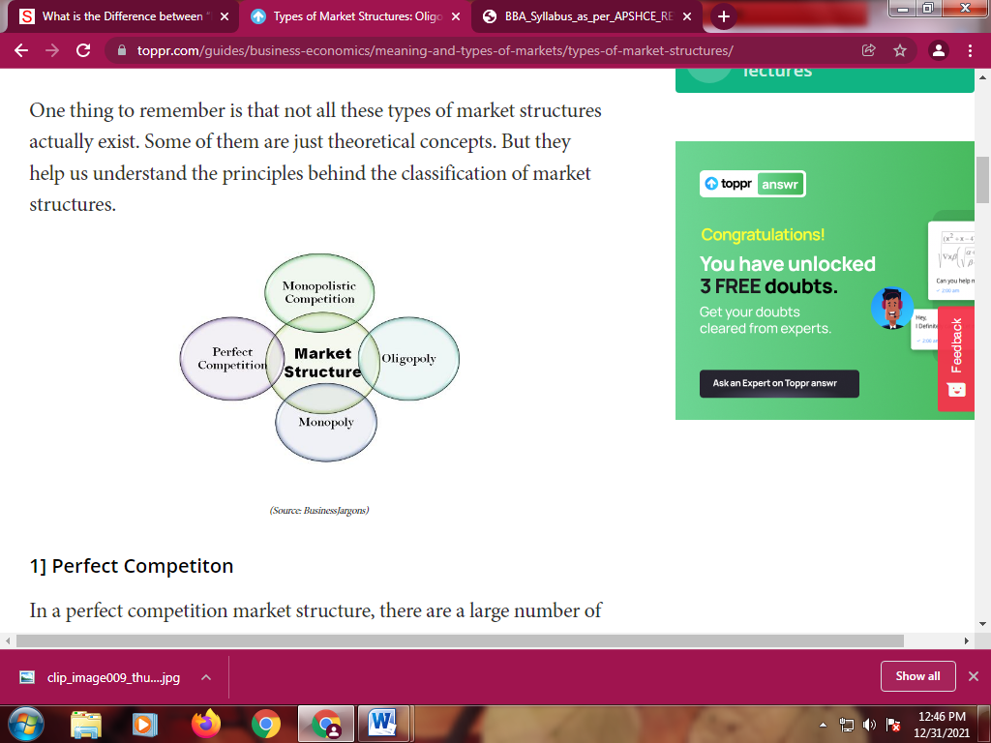

1] Perfect Competiton
In a perfect competition market structure, there are a large number of buyers and sellers. All the sellers of the market are small sellers in competition with each other. There is no one big seller with any significant influence on the market. So all the firms in such a market are price takers.
There are certain assumptions when discussing the perfect competition. This is the reason a perfect competition market is pretty much a theoretical concept. These assumptions are as follows,
- The products on the market are homogeneous, i.e. they are completely identical
- All firms only have the motive of profit maximization
- There is free entry and exit from the market, i.e. there are no barriers
- And there is no concept of consumer preference

2] Monopolistic Competition
This is a more realistic scenario that actually occurs in the real world. In monopolistic competition, there are still a large number of buyers as well as sellers. But they all do not sell homogeneous products. The products are similar but all sellers sell slightly differentiated products.
Now the consumers have the preference of choosing one product over another. The sellers can also charge a marginally higher price since they may enjoy some market power. So the sellers become the price setters to a certain extent.
For example, the market for cereals is a monopolistic competition. The products are all similar but slightly differentiated in terms of taste and flavours. Another such example is toothpaste.

3] Oligopoly
In an oligopoly, there are only a few firms in the market. While there is no clarity about the number of firms it dominant firms are considered the norm. So in the case of an oligopoly, the buyers are far greater than the sellers.
The firms in this case either compete with another to collaborate together, They use their market influence to set the prices and in turn maximize their profits. So the consumers become the price takers. In an oligopoly, there are various barriers to entry in the market, and new firms find it difficult to establish themselves.

4] Monopoly
In a monopoly type of market structure, there is only one seller, so a single firm will control the entire market. It can set any price it wishes since it has all the market power. Consumers do not have any alternative and must pay the price set by the seller.
Monopolies are extremely undesirable. Here the consumer loose all their power and market forces become irrelevant. However, a pure monopoly is very rare in reality.

UNIT-V
MACRO ECONOMICS ANLYSIS
Circular flow of income:
The circular flow of income or circular flow is a model of the economy in which the major exchanges are represented as flows of money, goods and services, etc. between economic agents. The flows of money and goods exchanged in a closed circuit correspond in value, but run in the opposite direction. The circular flow analysis is the basis of national accounts and hence of macroeconomics

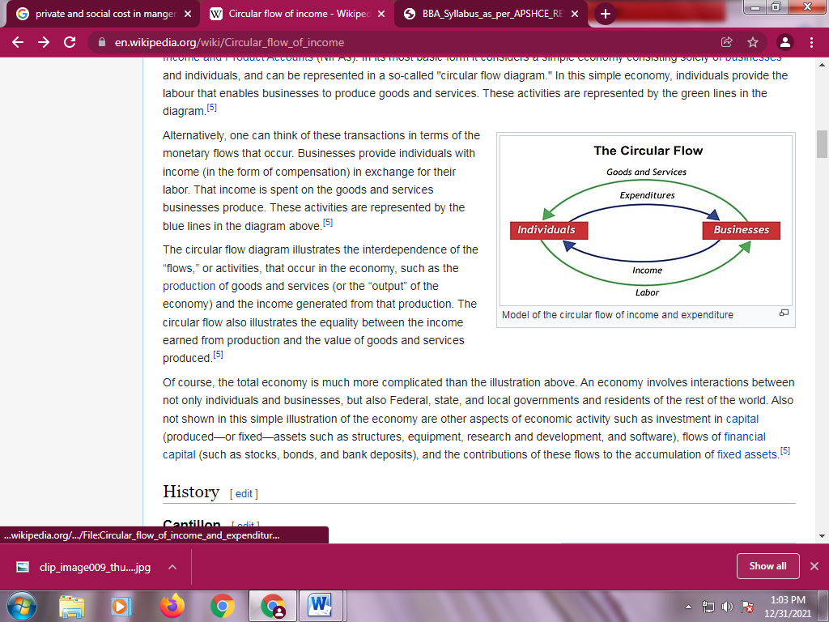
Types of models:

A circular flow of income model is a simplified representation of an economy

1. Two-sector model

In the basic two-sector circular flow of income model, the economy consists of two sectors:

- households
- firms.
Some sources refer to households as "individuals" or the "public"and to firms as "businesses" or the "productive sector."

The model assumes that there is no financial sector, no government sector, and no foreign sector. In addition, the model assumes that

(a) through their expenditures, households spend all of their income on goods and services or consumption and
(b) through their expenditures, households purchase all output produced by firms

This means that all household expenditures become income for firms. The firms then spend all of this income on factors of production such as labor,capital and raw materials, "transferring" all of their income to the factor owners (which are households). The factor owners (households), in turn, spend all of their income on goods, which leads to a circular flow of income.
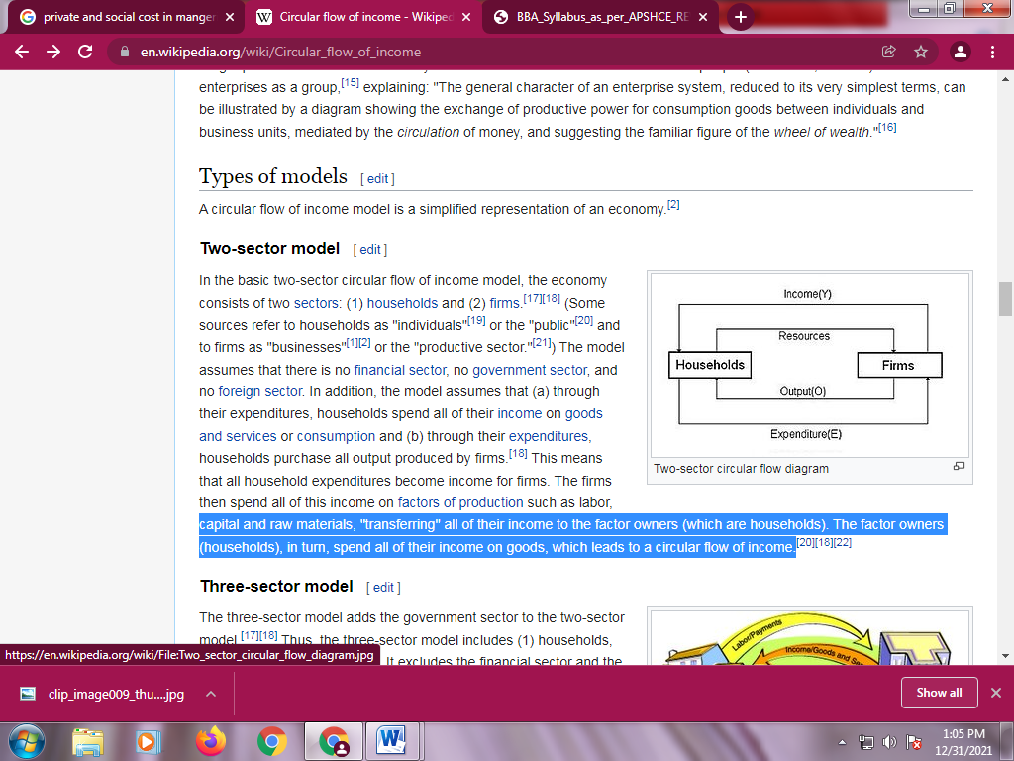

2.Three-sector model
The three-sector model adds the government sector to the two-sector model.^{[17][18]} Thus, the three-sector model includes
- Households
- Firms
- Government.

It excludes the financial sector and the foreign sector. The government sector consists of the economic activities of local, state and federal governments. Flows from households and firms to government are in the form of taxes.

The income the government receives flows to firms and households in the form of subsidies, transfers, and purchases of goods and services.Every payment has a corresponding receipt; that is, every flow of money has a corresponding flow of goods in the opposite direction.As a result, the aggregate expenditure of the economy is identical to its aggregate income, making a circular flow.

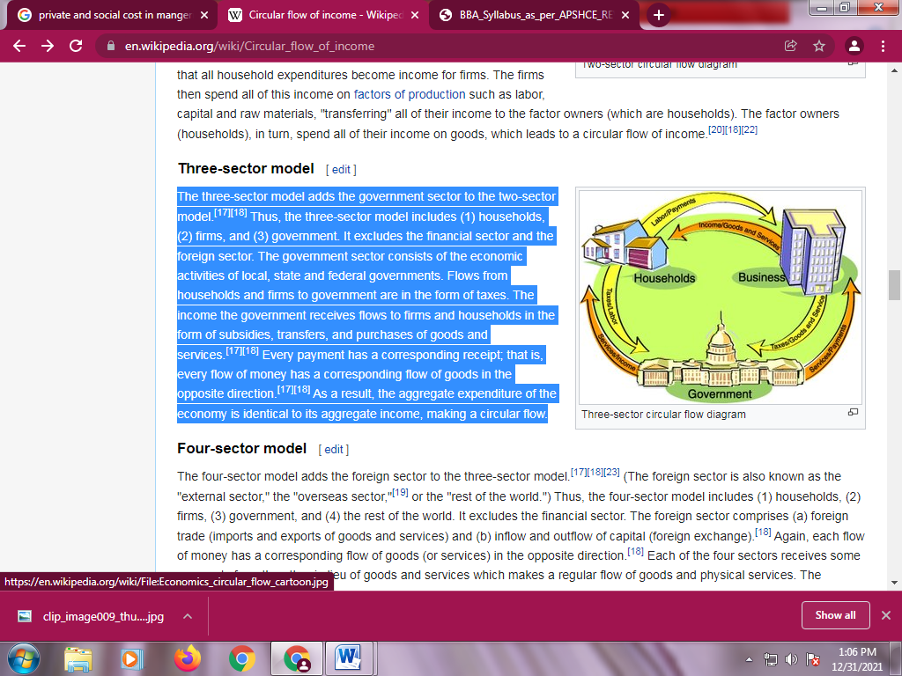

3. Four-sector model:
The four-sector model adds the foreign sector to the three-sector model.^{[17][18][23]} (The foreign sector is also known as the "external sector," the "overseas sector,"^{[19]} or the "rest of the world.") Thus, the four-sector model includes
(1) households,
(2) firms,
(3) government, and
(4) the rest of the world.

It excludes the financial sector. The foreign sector comprises (a) foreign trade (imports and exports of goods and services) and (b) inflow and outflow of capital (foreign exchange).^{[18]} Again, each flow of money has a corresponding flow of goods (or services) in the opposite direction.^{[18]} Each of the four sectors receives some payments from the other in lieu of goods and services which makes a regular flow of goods and physical services. The addition of the foreign sector

4. Five-sector model:
The five-sector model adds the financial sector to the four-sector model.Thus, the five-sector model includes
(1) households
(2) firms
(3) government
(4) the rest of the world
(5) the financial sector.

The financial sector includes banks and non-bank intermediaries that engage in borrowing (savings from households) and lending (investments in firms).^{[19]} Money facilitates such an exchange smoothly.

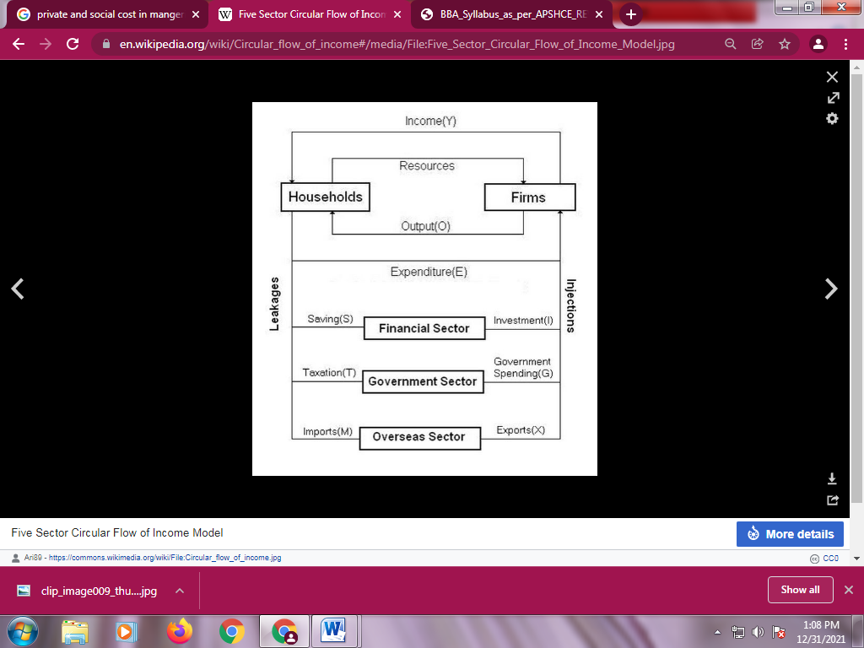

National Income
National Income of any country means the complete value of the goods and services produced by any country during its financial year. It is thus the consequence of all economic activities that are running in any country during the period of one year. It is valued in terms of money. In short one can say that the national income of any country is the total amount of income that is accrued by it through various economic activities in one year. It is also helpful in determining the progress of the country.
It includes wages, interest, rent, profit, received by factors of production like labour, capital, land and entrepreneurship of a nation.

National Income: Concept
There are various concepts of National Income including GDP, GNP, NNP, NI, PI, DI, and PCI which explain the facts of economic activities.
a. GDP at market price: Is money value of all goods and services produced within the domestic domain with the available resources during a year.
GDP = (P*Q)
Where,
GDP = gross domestic product
P = Price of goods and services
Q= Quantity of goods and services
GDP is made up of 4 Components
- consumption
- investment
- government expenditure
- net foreign exports of a country
GDP = C+I+G+(X-M)
Where,
C=Consumption
I=Investment
G=Government expenditure
(X-M) =Export minus import

b. Gross National Product (GNP): Is market value of final goods and services produced in a year by the residents of the country within the domestic territory as well as abroad. GNP is the value of goods and services that the country's citizens produce regardless of their location.
GNP=GDP+NFIA or,
GNP=C+I+G+(X-M) +NFIA
Where,
C=Consumption
I=Investment
G=Government expenditure
(X-M) =Export minus import
NFIA= Net factor income from abroad.
c. Net National Product (NNP) at MP: Is market value of net output of final goods and services produced by an economy during a year and net factor income from abroad.
NNP=GNP-Depreciation
or, NNP=C+I+G+(X-M) +NFIA- IT-Depreciation
Where,
C=Consumption
I=Investment
G=Government expenditure
(X-M) =Export minus import
NFIA= Net factor income from abroad.
IT= Indirect Taxes
d. National Income (NI): Is also known as National Income at factor cost which means total income earned by resources for their contribution of land, labour, capital and organisational ability. Hence, the sum of the income received by factors of production in the form of rent, wages, interest and profit is called National Income.
Symbolically or as per the formula
NI=NNP +Subsidies-Interest Taxes
or, GNP-Depreciation +Subsidies-Indirect Taxes
or, NI=C+G+I+(X-M) +NFIA-Depreciation-Indirect Taxes +Subsidies

e. Personal Income (PI): Is the total money income received by individuals and households of a country from all possible sources before direct taxes. Therefore, personal income can be expressed as follows:
PI=NI-Corporate Income Taxes-Undistributed Corporate Profits- Social Security Contribution +Transfer Payments.

f. Disposable Income (DI) : It is the income left with the individuals after the payment of direct taxes from personal income. It is the actual income left for disposal or that can be spent for consumption by individuals.
Thus, it can be expressed as:
DI=PI-Direct Taxes
g. Per Capita Income (PCI): It is calculated by dividing the national income of the country by the total population of a country.
Thus, PCI=Total National Income/Total National Population

Measurement of National Income
There are three methods to calculate National Income:
- Income Method
- Product/ Value Added Method
- Expenditure Method

- Income Method
In this National Income is measured as flow of income.
We can calculate NI as:
Net National Income = Compensation of Employees+ Operating surplus mixed (w +R +P +I) + Net income + Net factor income from abroad.
Where,
W = Wages and salaries
R = Rental Income
P = Profit
I = Mixed Income
- Product/ Value Added Method
In this National Income is measured as flow of goods and services.
We can calculate NI as:
NATIONAL INCOME = G.N.P – COST OF CAPITAL – DEPRECIATION – INDIRECT TAXES
- Expenditure Method
In this National Income is measured as flow of expenditure.
We can calculate NI through Expenditure method as:
National Income=National Product=National Expenditure.

INCOME AND EMPLOYEMT:

The income theory of money is also called saving-investment theory of money, which states that it is income that determines price and not the supply of money as stated by the quantity theory of money. The income theory of money states that changes in the aggregate demand are the resultant of changes in income, rather than supply of money. Thus, changes in the aggregate money income or nominal income, and not the supply of money, are the main determinants of aggregate demand and hence of prices. Increase in nominal income or money income leads to increase in aggregate demand and thereby increase in prices. In fact, supply of money may change due to change in the level of income, prices and economic activities

The term ‘income’ in this theory is interpreted in two senses: (i) nominal income/output, and (ii) real income/ real output. Nominal income is the monetary value of output such as price of output times the quantity of output (i.e., Y), and real output/income is the quantity of output (Q). So, price (P) is the ratio of changes in nominal income/output to the real income/output,

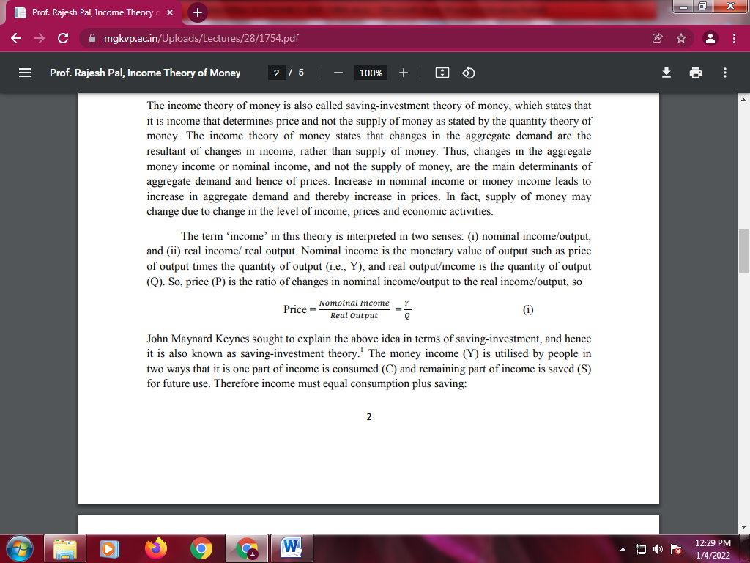

John Maynard Keynes sought to explain the above idea in terms of saving-investment, and hence it is also known as saving-investment theory.1 The money income (Y) is utilised by people in two ways that it is one part of income is consumed (C) and remaining part of income is saved (S) for future use. Therefore income must equal consumption plus saving
Y = C + S
Where, Y refers to income; C represents consumption; and S denotes saving. Saving means that part of income, which is not consumed; it can be expressed as
S = Y – C
In an economy, two types of expenditure are incurred, one by the household on consumer goods (C) and another by the corporate/ entrepreneurs on investment goods. As we know that expenditure of one man’s is income of another man, so it can be written
Y = C + I
The expenditure on consumer goods depends on the real income and the marginal propensity to consume (MPC),

Where, MPC is marginal propensity to consume; ∆C is change in consumption; and ∆Y is change in income. The investment expenditure depends on marginal efficiency of capital (i.e., profitability of capital) and the current rate of interest. Thus, income theory states that changes in income beings changes in expenditure that determines output and employment and prices. So it is income, which determines prices. When we summarised income theory we find that expenditure (E) is equal to income (Y), as

Therefore, the income theory of money is also called saving-investment theory. This credit for income theory and saving-investment theory is presented by Lord Keynes.

According to Keynesian theory economy will be in equilibrium if saving (S) equals investment (I). This is illustrated in Figure 1. Equilibrium income means the only income that the economy will be able to sustain, in that there is the balance of forces consistent with the actions of demanders and suppliers. It does not necessarily mean full employment. The total amount of output that could be produced under full employment is called potential Gross National Product (GNP).
When actual GNP and potential GNP differ, there is a GNP gap or income gap. When actual GNP is less than potential GNP (i.e., full employment), this GNP is called contractionary gap and when actual GNP is more than potential GNP, this is called expansionary gap. Gaps are only defined relative to full employment.

